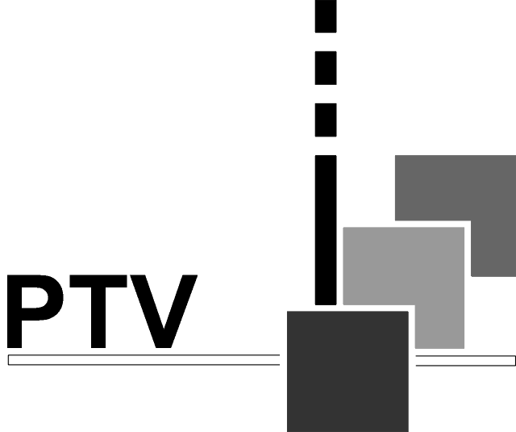
ProTeleVision Technologies A/S
Kornmarksvej 21
DK-2605 Brøndby
Denmark

PT 5664
Digital & Analog Component/
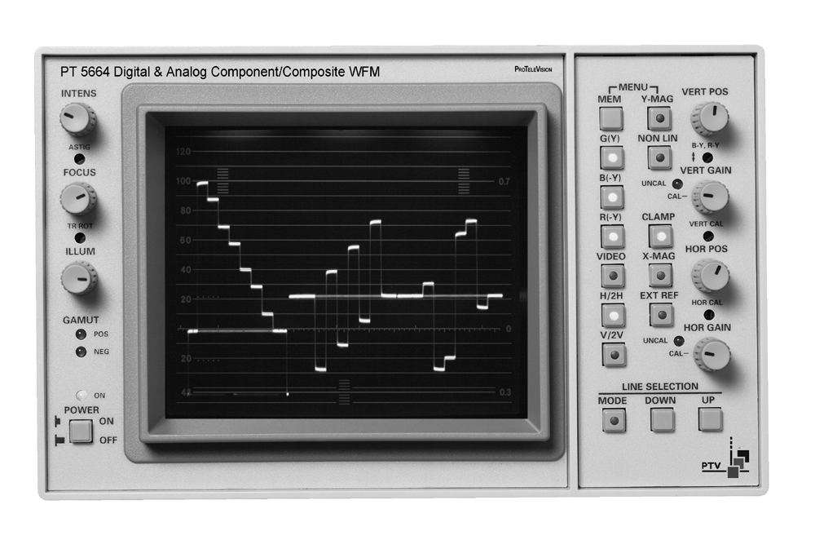
Composite WFM

Instruction Manual

 | ProTeleVision Technologies  An ISO 9001 Certified Company

PT 5664 Digital & Analog Component/Composite WFM: | Total number of pages: 48

Copyright © 1999 | ProTeleVision Technologies A/S, Denmark  All Rights Reserved
Printed in Denmark 99-05-03
Revision: 1
Publication number: 9499 493 10611

Contents

1 Safety 1-1
1.1 Introduction 1-1
1.2 Safety Precautions 1-1
1.3 Caution and Warning Statements 1-1
1.4 Impaired Safety Protection 1-1
1.4.1 Technical Specifications 1-1
1.4.2 Equipment Ratings 1-2
1.5 Electrostatic Sensitive Devices 1-2
1.6 Symbols 1-3
2 Introduction and Applications 2-1
2.1 General 2-1
2.2 Applications 2-2
2.2.1 WAVEFORM mode 2-2
2.2.2 PARADE mode 2-2
2.2.3 STAR mode 2-2
2.2.4 VECTOR mode 2-2
2.2.5 BOW TIE mode 2-3
2.2.6 TEST mode 2-3
3 Product Data 3-1
3.1 Safety characteristics 3-1
3.2 Performance characteristics 3-1
3.3 Versions 3-1
3.3.1 Options 3-1
3.4 Video Input selection 3-1
3.5 Serial Digital Video 3-2
3.6 Analog Video inputs 3-2
3.7 External reference input 3-2
3.8 Pix monitor output 3-3
3.8.1 RGB mode 3-3
3.8.2 Colour difference mode 3-3
3.8.3 Gamut error detector 3-3
3.9 Filters 3-3
3.9.1 NON-LINEARITY 3-4
3.10 Vertical amplifier 3-4
3.10.1 Deflection sensitivity 3-4
3.11 Clamp 3-4
3.12 Calibrator 3-4
3.12.1 Time calibration 3-4
3.12.2 Amplitude calibration 3-5
3.13 Horizontal system 3-5
3.13.1 Time base 3-5
3.13.2 Parade display 3-6
3.13.3 Bowtie display 3-6
3.14 X-Y displays 3-6
3.14.1 Vector display 3-6
3.14.2 Star display 3-6
3.15 Environmental conditions 3-6
3.15.1 Temperature range 3-6
3.15.2 Mechanical requirements 3-7
3.16 Power supply 3-7
3.17 Mechanical data 3-7
4 Accessories & options 4-1
4.1 Accessories 4-1
4.2 Options 4-1
5 Installation 5-1
5.1 Initial inspection 5-1
5.2 Safety instruction 5-1
5.2.1 Earthing 5-1
5.3 Mains voltage setting and fuses 5-1
5.4 Configuration 5-2
5.4.1 Formats 5-2
5.4.2 Input format selection. 5-2
5.4.3 Gamut indicator 5-3
5.4.4 External reference input 5-3
5.5 Rack mounting 5-4
5.5.1 Free air convection 5-4
5.5.2 Forced circulation 5-4
6 Operating Instructions 6-1
6.1 Front panel controls 6-1
6.2 Rear panel connections 6-4
6.3 Main MENU (MODE) selection 6-6
6.3.1 Input format 6-6
6.4 WAVEFORM display mode 6-7
6.4.1 WFM Display format 6-8
6.5 PARADE display mode 6-8
6.6 STAR display mode 6-9
6.6.1 Transcoder display 6-11
6.7 VECTOR display mode 6-12
6.7.1 Transcoder display 6-12
6.7.2 TEST GRID facilities 6-12
6.8 BOWTIE display mode 6-14
6.9 TEST mode 6-15
6.10 Line selection 6-16
6.10.1 General 6-16
6.10.2 Waveform mode 6-17
6.10.3 Vector mode 6-17
6.11 Gamut error detection 6-17
6.12 Master reset of the PT 5664 6-18
6.13 Memory functions 6-18
6.13.1 Front panel controlled memories 6-18
6.13.2 Remote controlled memories 6-19
7 Service and Maintenance 7-1
7.1 Main functions of the units 7-1
7.1.1 Power Supply 7-1
7.1.2 CRT Control 7-1
7.1.3 Deflection Amplifiers 7-1
7.1.4 Signal Processor 7-1
7.1.5 Potentiometer Board 7-3
7.1.6 Keyboard 7-3
7.1.7 SDI and Control Board 7-3
7.1.8 RGB Monitor Out 7-3
7.2 Access to units 7-3
7.2.1 Removing the Cover 7-3
7.2.2 Access to and Removal of the Signal Processor (Unit 4) and SDI and
Control Board (unit 7) 7-4
7.2.3 Access to and Removal of the Power Supply - Unit 1 7-5
7.2.4 Access to and Removal of the CRT Control Unit - Unit 2 7-5
7.2.5 Access to the Deflection Amplifier - Unit 3. 7-6
7.2.6 Access to the Potentiometer Board - Unit 5 and the Keyboard - Unit 6 7-6
7.2.7 Access to the RGB Monitor Out Unit - Unit 8. 7-6
7.2.8 CRT Replacement 7-6
7.3 Power Supply - Unit 1 7-8
7.3.1 General Information 7-8
7.3.2 Circuit Description 7-8
7.3.2.1 Mains Rectifier 7-8
7.3.2.2 Converter Circuit 7-9
7.3.2.3 DC Output 7-9
7.3.2.4 Voltage Control - Reference 7-9
7.3.2.5 Optocoupler 7-9
7.3.2.6 Voltage Protection 7-9
7.3.2.7 High Voltage Generator - Tripler 7-10
7.3.2.8 Trace Rotation 7-10
7.3.2.9 Illumination Control 7-10
7.3.2.10 Z-Amplifier 7-10
7.3.2.11 AC/DC Converter (Unit 1A) 7-10
7.3.2.12 Black Level (Unit 1A) 7-10
7.3.2.13 Focus Voltage Conversion 7-11
7.4 CRT Control - Unit 2 7-11
7.5 Deflection Amplifiers - Unit 3 7-12
7.5.1 General Information 7-12
7.5.2 Circuit Description 7-12
7.5.2.1 Horizontal Output Amplifier 7-12
7.5.2.2 Vertical Output Amplifier 7-12
7.6 Signal Processor - Unit 4 7-12
7.6.1 General Information 7-12
7.6.2 Circuit Description 7-13
7.6.2.1 Input Buffer and switches 7-13
7.6.2.2 Calibration Generator 7-13
7.6.2.3 Monitor Matrix 7-13
7.6.2.4 Display Matrix 7-14
7.6.2.5 Vertical Selector 7-14
7.6.2.6 Non-Linearity Filter 7-14
7.6.2.7 Variable Gain Vertical 7-14
7.6.2.8 Polarity Switch and Buffer, Vertical 7-15
7.6.2.9 Multiple Clamp, Vertical 7-15
7.6.2.10 Vertical-LP Filter 7-15
7.6.2.11 Vertical Drive Amplifier 7-15
7.6.2.12 Horizontal Selector, Variable Gain (H), Polarity Switch,
Buffer Multiple Clamp (H), and Horizontal LP-Filter. 7-15
7.6.2.13 Time Base 7-16
7.6.2.14 Horizontal Drive Amplifier 7-16
7.6.2.15 Microprocessor Interface 7-16
7.6.2.16 Free Run Oscillator and Clamp Generator 7-17
7.6.3 Test and adjustments 7-17
7.6.3.1 Black level - R4/R6. 7-17
7.6.3.2 DC balance - R7/R22/R37. 7-17
7.6.3.3 DC balance on Ymag - R50 (unit 3). 7-17
7.6.3.4 Centering of sync - R26. (Unit 3) 7-18
7.6.3.5 Level meter - R2712 7-18
7.6.3.6 Cal generator amp - R53 7-18
7.6.3.7 Sawtooth gain - R545 7-18
7.6.3.8 Sawtooth gain - R524 7-18
7.6.3.9 Vertical drive freq. response - C206/C324 7-18
7.6.3.10 Delay - H-cal gain. 7-18
7.6.3.11 Vertical drive (variable gain) freq. response - C406 7-19
7.6.3.12 H-Graticule size - R533 7-19
7.6.3.13 STAR RGB gain - R540 7-19
7.6.3.14 STAR VECTOR gain - R316 7-19
7.7 Potentiometer Board - Unit 5 7-19
7.8 Keyboard - Unit 6 7-19
7.9 Control Board - Unit 7 7-19
7.9.1 General Information 7-19
7.9.2 Circuit Description 7-20
7.9.2.1 Microprocessor Circuit 7-20
7.9.2.2 Reset Circuit 7-20
7.9.2.3 Remote Control Input 7-21
7.9.2.4 Intensity Control 7-21
7.9.2.5 Display/Keyboard Circuit 7-21
7.9.2.6 Graticule Generator 7-21
7.9.3 Adjustments 7-22
7.9.3.1 Adjustment of SDI input. 7-22
7.9.3.2 Adjustment of SDI to analog converter. 7-22
7.10 RGB Monitor Out - Unit 8 7-23
7.10.1 General Information 7-23
7.10.1.1 Circuit Description 7-23
7.10.1.2 RGB Video Buffers 7-23
7.10.1.3 Composite Video Amplifier 7-24
7.10.1.4 Gamut Detector 7-24
7.10.2 Test and adjustments: 7-24
7.10.2.1 Monitor out gain - R66 7-24
7.10.2.2 Gamut test - R36/R43 7-24

Safety
Read this chapter carefully before installation and use of the instrument.

Introduction
The instrument described in this manual is designed to be used by properly trained personnel only.

Adjustment, maintenance and repair of the exposed equipment shall be carried out only by qualified personnel who are aware of hazards involved.

Safety Precautions
For the correct and safe use of the instrument, it is essential that both operating and servicing personnel follow generally accepted safety procedures in addition to the safety precautions specified in this manual. Specific warning and caution statements, where applicable, are found throughout this manual. Warning and caution statements and/or symbols are marked on the instrument where necessary.

Caution and Warning Statements
Caution
Used to indicate correct operation or maintenance in order to prevent damage to, or destruction of equipment or other property.

Warning
Used to indicate a potential hazard that requires correct procedures or practices in order to prevent personal injury.

Impaired Safety Protection

Technical Specifications
This manual provides technical information important for safe operation of the equipment.

Please refer to the Chapter Product Data for information regarding technical specifications and the Chapter Installation and Operating Instructions regarding instructions for use.

Technical assistance may be obtained from your local ProTeleVision customer support organization or from:
ProTeleVision Technologies A/S
Kornmarksvej 21
DK-2605 Brøndby
Denmark
Phone: +45 4329 2300
Fax: +45 4329 2323
E-Mail: helpdesk@ptv.dk
Website: http://www.ptv.dk

Equipment Ratings
The instrument can be used with a mains voltage supply of:
Voltage:
90 V AC - 250 V AC.
Frequency:
48 – 65 Hz.
The power consumption:
Does not exceed 72 VA.

The instrument is designed for the following environmental conditions:
Indoor use
Altitudes up to 2000 m
Temperatures between 5ºC and 40ºC
Maximum relative humidity of 80% for temperatures up to 31ºC decreasing linearly to 50% relative humidity at 40ºC.

The instrument is equipped with a number of input and output terminals as described in the Chapter Product Data.

The terminals are protected from becoming hazardous live by means of basic insulation and protective screening.

Whenever it is likely that safe operation is impaired, the instrument must be made inoperative and secured against unintended operation. The appropriate servicing authority must be informed.

For example, safety is likely to be impaired if the instrument fails to perform the intended measurements or shows visible damage.

WARNING: Protection provided by the equipment may be impaired, if the equipment is used in a manner not specified by this manual.


ATTENTION

Electrostatic Sensitive Devices
All ICs and many other semi-conductors are susceptible to electrostatic discharges ESD). Careless handling during repair can reduce lifetime drastically.

When repairing, make sure that you are connected to the same potential as the mass of the set via a wrist wrap with resistance. Keep components and tools also at this potential.

Symbols
Symbol | Color: | Explanation:
 | Red | High voltage terminal: a terminal at which a voltage, with respect to another terminal or parts exists or may be adjusted to 1000 V or more. (High voltage > 1000 V).
 | Black/Yellow | Live part shock risk of electric shock.
 | Black/Yellow | To preserve the instrument from damage the operator must refer to an explanation in the instruction manual.
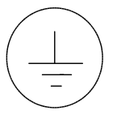 | White/Black | Protective earth (grounding) terminal.
~ | Black | Alternating current (placed on the indetification plate).
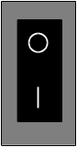 | White/Black | Off (supply - mains switch).  On (supply - mains switch).

Introduction and Applications

General
The PT 5664 Digital & Analog component/composite WFM is a multiformat waveform monitor and vectorscope for digital and analog component signals. Pushbuttons on the front enable switching between the display of SDI or analog component.

The PT 5664 automatically adjusts to 525-lines or to 625-lines system.

PT 5664 covers the following input formats:
- SDI (serial Digital Component)
- Y, P_{B}, P_{R} (analog component, SMPTE/EBU format)
- RGB
- BETACAM, 3-wire
- M II, 3-wire
- M II, 2-wire (only Waveform mode)
- Composite video signals

It provides the well-known display for both the analog component and digital SDI signals, i.e. waveform, parade, vector, star etc.

In the waveform and parade the display format is selectable between the YP_{B}P_{R} or RGB display.

The PT 5664 has the following inputs:
- One SDI input
- One set of analog component inputs
- One Analog Composite input
The inputs are selectable by means of pushbuttons on the front.

The PT 5664 provides the following outputs:
- The digital interface provides a re-clocked and cables equalised SDI output of the incoming SDI signal
- The PIX-monitor output is a RGB output for monitoring purpose only

SDI and YP_{B}P_{R} inputs are automatically converted to the RGB format. The output has also overlay of the gamut detection, indicating visually where the colour space has been violated.
A violation of the colour space is also indicated with the Gamut LED’s on the front plate.

Main functions are directly accessible by means of pushbuttons, while format settings and more special features are menu-controlled.

Applications
The PT 5664 digital & analog component/composite waveform monitor is designed for alignment and monitoring of signals in analogue component and composite based environments such as TV studios and OB vans (outside broadcasting), Production houses etc.

For this application the following display-modes are available:
- WAVEFORM
- PARADE
- STAR
- VECTOR
- BOWTIE
- TEST

WAVEFORM mode
In WAVEFORM mode the SDI signal or the analog component signals can be displayed as represented by their individual components.

The WAVEFORM mode also has the possibility to overlay the signals in either SDI or analog component. Two or three components can be displayed overlaid onto each other. When the composite video input is selected, one component can additionally be selected to produce a component/video overlay display. Waveforms can be shown in either H, 2H, V or 2V display.

PARADE mode
The PARADE mode shows the three component-/colour difference signals side by side, either from the SDI input or from the analog component input.

In Y/P_{B}/P_{R} display mode the P_{B}/P_{R} components are clamped to the 50% level on the screen.

When the Video Input is selected, one (selectable) component signal is shown together with the video signal in the parade display. H- as well as V-mode can be chosen.

STAR mode
With the STAR mode, timing and amplitude errors between the components of the signal, can be monitored using a plain colourbar as reference signal.

Component based signals from sources such as a VTR or camera are particularly sensitive to timing and amplitude errors in the signal path. A timing error results in coloured edges and an amplitude error results in discolouring of the picture. The Star display in magnified mode is designed especially to reveal such errors. To ensure a correct alignment, measuring dots can be switched on, to facilitate the detection of timing errors in the video signal.

VECTOR mode
The VECTOR mode shows the colour phases and amplitudes of the component signals.

BOW TIE mode
The Bow tie measurement is used for alignment of amplitude and timing in studio systems, but for this measurement a special test signal is needed. With this special signal higher accuracy can be obtained than with the STAR display.

TEST mode
Several test facilities for the alignment of studio equipment are available:
- 700mV test display
This function shows a fixed indication of the 700 mV level.

- Variable off-set test display
Indicates a selected level on the display. The selected level is shown in mV on the display. The level can be varied from –500 mV to +1500 mV.

- 100kHz square wave display
To check the horizontal timing and the vertical deflection in Waveform mode, a 100 kHz square wave signal with amplitude of 1V_{PP} is provided from an internal generator.

- G(Y) & EXT reference ALT display
This mode offers a waveform display of the G(Y) component signal alternating with the external reference signal. This gives the possibility to check the timing between the two signals.

- G(Y) – EXT
This mode offers a waveform display of the subtraction between the G(Y) component and the external reference signal. The feature offers the possibility to check the timing between the two signals.

- EXT
Shows the signal applied at the EXTERNAL REF connector.

Product Data

Safety characteristics
This apparatus has been designed and tested in accordance with Safety Class I requirements of IEC publication 348 (Safety requirements for Electronic Measuring Apparatus), and has been supplied in a safe condition. This manual contains information and warnings, which must be followed to ensure safe operation and to retain the apparatus in a safe condition.

Warning: For safety reasons PT 5664 must be mounted in one of the cabinets PM 8539,
PM 8541 or PM 8543. The PT 5664 must only be installed by use of the screws and washers mounted on the rear plate of the instrument to obtain a safe condition before it is switched on.

Performance characteristics
Properties expressed in numerical values with stated tolerances are guaranteed by ProTeleVision Technologies. Specified non-tolerance numerical values indicate those that could be nominally expected as a mean of a range of identical instruments.

Versions
The PT 5664 automatically adjusts to the correct television system. If the system is non-interlaced (like 524 or 624 line) this will be indicated as by an “NI” on the screen.
The Graticule is universal for 0-700mV component signals and has specific markings for analog composite video in 625-lines. The built-in transcoder is a SMPTE/EBU type, which converts SDI (and 625-lines BETACAM) into correct RGB values.

Options
PM 8539 19" rack cabinet
PM 8540 Blind plate for PM 8539
PM 8541 Carrying case
PM 8542/20 Interface cable for connection to PM 5667/PM5668
PM 8543 Cabinet, plain

Video Input selection
The SDI input, analog component video inputs and the composite video input on the rear panel can be selected from the front panel for display on the CRT.
The component channels can be switched on/off individually and one input can be substituted with the composite video input.

Serial Digital Video
According to standards: SMPTE259M and ITU-656.

SDI Input:
- Return loss: >15 dB, 5-270 MHz
- Cable Equalisation: 0-300m typical, @Belden 8281
- Display formats: as for analog YP_{B}P_{R,} The composite input can be selected for display as
one of the channels
SDI output:
- Return loss: >15 dB, 5-270 MHz
- Rise Time: 600 ps typical
- Jitter: ±250 ps typical (with 250 ps input jitter)

Analog Video inputs
The analog component video inputs can either be in the YP_{B}P_{R} or in the RGB format. The composite input can be selected for display as one of the channels.

Input 1: G or Y
Input 2: B or B-Y
Input 3: R or R-Y
Input 4: Composite video
Note:
The colour difference signals B-Y and R-Y equals the P_{B} and P_{R} signals respectively.
- Connector: 8 x BNC
- Impedance: High ohmic, 75Ω looped through
- Return loss: >40 dB up to 7 MHz
- Max. input: 2 V_{PP} AC, less than -2/+6 VDC
- Gain difference between inputs: <1% at 0.5 MHz and at 5 MHz
- Timing error between inputs: <5 ns
- Crosstalk between inputs: Better than –70 dB at 5 MHz
- Crosstalk from non-selected input to screen: Better than –46 dB up to 5 MHz

External reference input
The time base, the sequence switch, and the clamp pulse generator are locked to the sync information from input, G(Y), the composite input, or the external reference input. Selection of the reference input internal or external is done by a front panel push button.
- Signal requirement: Composite sync 150mV to 4V (internal selectable, see section 5.4.4) or composite video nominal level 6dB
- Connector: 2 x BNC
- Impedance: High ohmic, 75Ω looped through
- Return loss: Better than 40 dB up to 7 MHz
- Max input signal: 5 V_{PP}AC, less than ±2 VDC
- Superimposed hum: Less than 1 V_{PP}
- Crosstalk between EXT REF and inputs G(Y), B(-Y), R(-Y): Better than –60 dB at 5 MHz

Pix monitor output
This output is always in RGB format. If the input is colour difference signals (formats such as SDI, Y/P_{B/}P_{R,} MII, or Betacam) an automatic transcoding to RGB format takes place. A gamut detector monitors the RGB outputs to detect signal levels exceeding predetermined limits.
The gamut indication may be switched on/off by use of an internal programming plug, see section 5.4.3.
- Connector: 3 x BNC
- Impedance: 75Ω
- Return loss: Better than 34 dB up to 6 MHz

RGB mode
- Gain ratio: Within 0.3 dB
- Frequency response: 50 kHz to 6 MHz within 0.5 dB

Colour difference mode
- Gain accuracy: Within 0.3 dB
- Frequency response: 50 kHz to 6MHz within 1 dB

Gamut error detector
Band limitation ensures that very short aberrations with low amplitude in the video signal does not trigger the gamut detectors.
- Bandwidth of detectors: Approx. 1 MHz

- Lower limit preset: -35 mV ±5 mV
- Upper limit preset: 735 mV ± 5 mV

Filters
Filters for frequency response change are selectable by menu operation.

FLAT:
Amplitude response (analog inputs):
- 50 kHz to 6 MHz: Within ± 2%
- 6 MHz to 10 MHz: Within +2% to -10%
- Smooth roll-off above 6 MHz

Amplitude response (SDI inputs):
- 50 kHz to 5.75 MHz: Within ± 2%
- Above 5.75 MHz fast attenuation

LOW PASS:
Amplitude response:
- Attenuation less than 3 dB at 1 MHz ± 0.1 MHz, more than 26 dB at f_{SC}

NON-LINEARITY
Amplitude response:
- Bandpass filter, center frequency at 325 kHz with increased gain to obtain 280 mV_{PP}spikes from 140 mV riser in staircase
- Inherent error: Less than 0.25%

Vertical amplifier

Deflection sensitivity
- Video input: 1 V full scale ± 1%
- 5x magnifier: 0.2 V full scale ± 2%
- Max deflection (Y-MAG off): 2 x screen height
- Vertical positioning (Y-MAG off): 3 x screen height
- Gain range: Fixed gain +3 dB to -11.5 dB

The following specifications apply to the display of 1V video signal through the video inputs, when the gain is 1V full scale, no filters selected, and clamp on:
- 2T k-rating: Better than 0.25%
- 2T pulse to bar ratio: Better than 100% ± 1%
- Bar tilt:Less than 1%
- Field square wave tilt: Less than 0.5%

Clamp
The slow clamp (DC-restore) can be switched on and off by a front panel push button and has barely any attenuation of superimposed hum. This means that the clamp is slow enough to let hum pass to the display for monitoring:
- Hum attenuation: Less than 1 dB
- Black level shift due to change in APL from 10% to 90%: Less than 10 mV

Calibrator
The calibration generators can be activated in TEST mode by menu operation.

Time calibration
100 kHz SQUARE WAVE SIGNAL:
- Frequency: 100 kHz ± 100 Hz crystal controlled
- Amplitude: 1 V_{PP} ± 2%
- G(Y) & EXT. ALT: Input G(Y) and external reference signals superimposed
- Timing error between G(Y) input and external reference: Less than 10ns
- G(Y) - EXT.: Input G(Y) and external reference signals subtracted
- Accuracy: Better than 3%

Amplitude calibration
700mV FIXED:
- Signal type: Half sweep rate square wave; selectable superimposition on input signal G(Y), B(-Y), R(-Y), or composite video
- Amplitude: 700 mV ± 1%
VARIABLE:
- Signal type: Half sweep rate square wave; selectable superimposition on input signal G(Y), B(-Y), R(-Y), or composite video
- Amplitude range: -500 mV to +1500 mV in 1mV steps
- Amplitude accuracy: ±1% of reading ±1mV (±1 digit)

Horizontal system

Time base
ALL LINES:
1 V: Equal to field rate
2 V: Equal to frame rate.
1 H: Equal to line rate.
2 H: Equal to half line rate.
1 LINE:
F 1: Single line of field 1
F 2: Single line of field 2
Both: Single line of both fields
SELECTABLE LINE NUMBERS:
625 line system: line 1 to 625
525 line system: line 1 to 263 field 1 and line 1 to 262 field 2
Automatic switching between 625 lines and 525 lines dependent on the input.
MAGNIFICATION (X-MAG):
1 V: 25 times
2 V: 25 times
2 H: 10 times (equals 1µsec/div)
H & 1 line modes: 25 times (equals 0.2µs/div)
SWEEP LENGTH:
2 V: 12.8div. ±0.5div.
2 H: 12.4div. ±0.1div.
1 H 11.9div. ±0.5div.
- Accuracy 1µsec/div: 2 H + X-MAG: Better than 3% excluding first and last division
- Linearity: Better than 3% excluding the first and last division

Parade display
- Sweep repetition (Time Base): H/3 or V/3 rate
- Display sequence: Depending on input format and selected display format:
- G(Y), B(-Y) and R(-Y) for difference signals
- R,G and B for RGB analog RGB inputs or with selected RGB display

Bowtie display
- Display sequence: G(Y) - B(-Y) and G(Y) - R(-Y)

X-Y displays
The vector mode is selectable by menu operation.

Vector display
Graticule selectable for 75% and 100% colourbars. Tolerance boxes: ± 2%.
- Vertical input: R(-Y)
- Horizontal input: B(-Y)
- 3dB bandwidth: 1 MHz ± 0.1 MHz
- Horizontal to vertical matching: No eye openings (250kHz T/2 square wave signal)
- Gain accuracy: ± 1%
- X-MAG & Y-MAG gain: 5 times ± 2%

Star display
Graticule for 75% and 100% colourbars. Tolerance boxes: ± 2%.
- Vertical input: G(Y)
- Horizontal input: B(-Y), -R(-Y) lines alternating
- 3 dB bandwidth: 1 MHz ± 0.1 MHz
- Horizontal to vertical matching: No eye openings (250kHz T/2 square wave signal)
- Gain accuracy: ± 1%
- X-MAG & Y-MAG gain: 5 times ± 2%
- Timing markers for delay measurement: 40, 80 and 160ns

Environmental conditions

Temperature range
- Operational temperatures: 0°C to 45°C (32°F to 113°F)
- Storage temperatures: -30°C to 70°C (-22°F to 158°F)

EMI data:
- Comply with VDE 0871/DIN 57871 class B

Mechanical requirements
VIBRATION:
Limit range for storage and transport:
30min. in each of three directions, 10 to 150 Hz; 0.7 mm_{PP} and 50 m/s² max. acceleration. According to IEC-Publ. 68, test Fc.
NOTE:
Unit mounted on vibration table without shock absorbing material.

BUMP:
Limit range for storage and transport:
1000 bumps of 100m/s² sine, 6ms duration in each of 3 directions. According to IEC-Publ.68, test Eb.

Power supply
- Electrical safety: According to IEC 348, class I
- Mains supply voltage: 85 to 240VAC
- Mains supply frequency: 48 to 65 Hz
- Power consumption: 72 W at 100 to 240 V

Mechanical data
Height: 133 mm (52.36")
Width: 216 mm (85.04")
Depth: 465 mm (183.07")
Weight: 6.5 kg (14.33 lbs)

Accessories & options

Accessories
Item | Quantity | Ordering Number
Mains cable, EU | 1 | 5322 321 10388
Mains cable, US |  | 5322 321 10123
Instruction Manual | 1 | 9499 493 10611

Options
Item |  | Ordering Number
PM 8539 | 19” rack cabinet with space for two instruments mounted side by side | 9449 085 39001
PM 8540 | Blind palte for rack cabient, covers half rack size | 9449 085 40001
PM 8541 | Cabinet with handle | 9449 085 41001
PM 8542/20 | Cable to interface to PM 5567/PM 5668 | 9449 085 42201
PM 8543 | Cabinet plain | 9449 085 43001

Installation

Initial inspection
Check the contents of the shipment for completeness and possible transport damage. If the contents are incomplete or damaged, a claim should be filed with the carrier immediately and the ProTeleVision Sales or Service organisation should be notified in order to facilitate the repair or replacement of the instrument.

Safety instruction

Earthing
Before any other connection is made, the instrument must be connected to a protective earth conductor via the three-core mains cable.

Before connecting the equipment to the mains of the building installation, the proper functioning of the protective earth lead of the building installation needs to be verified.

WARNING: Any interruption of the protective conductor inside or outside the instrument, is likely to make the instrument dangerous. Intentional interruption is prohibited.

Mains voltage setting and fuses
Different power cords are available for the various voltage outlets. The delivered cord version is determined to the particular instrument version ordered.

Note: If the mains plug has to be adapted to the local situation it should only be done by a qualified person.

This instrument is equipped with a tapless switch-mode power supply that covers most nominal voltage rangers in use: 85-240 V AC RMS, or 125 to 240 V DC This obviates the need to adapt to the local mains voltage. The mains frequency is 48-65 Hz or DC.

WARNING: This instrument shall be disconnected from all voltage sources when renewing a fuse.

Fuse rating: 1.5 A delayed action, 250 V.

The mains fuseholder is located on the rear panel of this instrument.

If the mains fuse has to be replaced please proceed as follows:
- Remove mains cord
- Remove the fuse by turning around the top of the fuseholder. This by means of a crewdriver
- Fit the new fuse into the top of the fuseholder
- Refit the part of the fuseholder into the previous position

WARNING: Make sure that only fuses of the required current and voltage, and of the specified type are used for replacement.
The use of repaired fuses and/or shortcircuit of the fuseholder is prohibited.

Configuration

Formats
The PT 5664 accepts inputs such as SDI, analog component (RGB, Y/P_{B}/P_{R)} ) and analog composite video.

The analog input formats can either be RGB, YP_{B}P_{R}, BETACAM or MII. The instrument is configured for actual format by simple front panel operation.
The SDI input is digital component, 270 Mbit/s according to SMPTE 259 and ITU-656.

Input format selection.
For selection of input format please see section 6.4.

PT 5664 is mounted with a SMPTE/EBU transcoder, YP_{B}P_{R} to RGB.
When applying a 100% colourbar to the PT 5664 the output of the transcoder (PIX MON OUTPUTS) will be as follows:

Analog input:
Y-component : 700 mV
P_{B}-component : ± 350 mV
P_{R}-component : ± 350 mV

SDI-input:
Input according to ITU-601.

Output:
R-component : 700 mV
G-component : 700 mV
B-component : 700 mV

In case set-up is applied on the Y-component input, it will result in set-up with equal amplitude on all three component-outputs.

Access to internal configuration
In case hardware configuration is needed use the following procedure:

SAFETY
The opening of covers or removal of parts, expect those to which access can be gained by hand is liable to expose live parts. Accessible terminals may also be live. The instrument must be disconnected from all voltage sources before performing any adjustment, replacement, maintenance or repair which requires the instrument to be opened. If adjustment, maintenance or repair of the opened instrument is unavoidable, it must only be carried out by a skilled person who is aware by hazards involved.

Remove the PT 5664 chassis by unscrewing the two screws "A" on the rear panel. Pull the instrument out of the chassis.

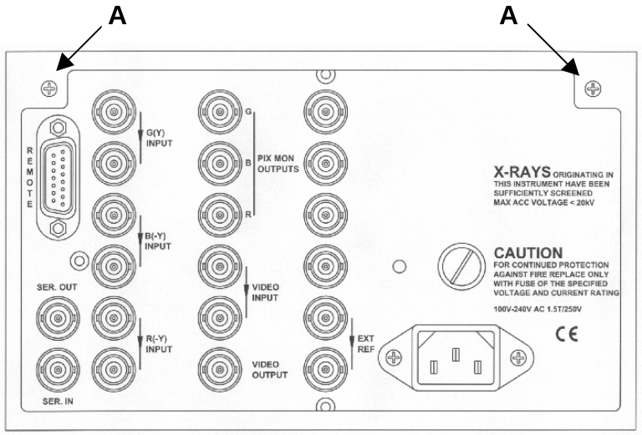

Fig. 5-1 Rearplate

Gamut indicator
The gamut indicator on the PIX MONITOR outputs can be switched on/off by replacing a programming plug on the PIX monitor unit.
From the factory is the PT 5664 delivered with gamut on.

To change the setting please use the following procedure:
- Open the instrument as shown in section 5.4.2
- Place the programming plug PP1 according to fig. 5-2

External reference input
The external reference input may be modified from 150-400mV to 4V sync signal by selecting a 10:1 division circuit on/off. This is done by replacing a programming plug on the control board unit.
From the factory is the PT 5664 delivered with the programming plug in position 150-400mV sync signal.

To change the setting please use the following procedure:
- Open the instrument as shown in section 5.4
- Place the programming plug PP2 according to fig. 5-2

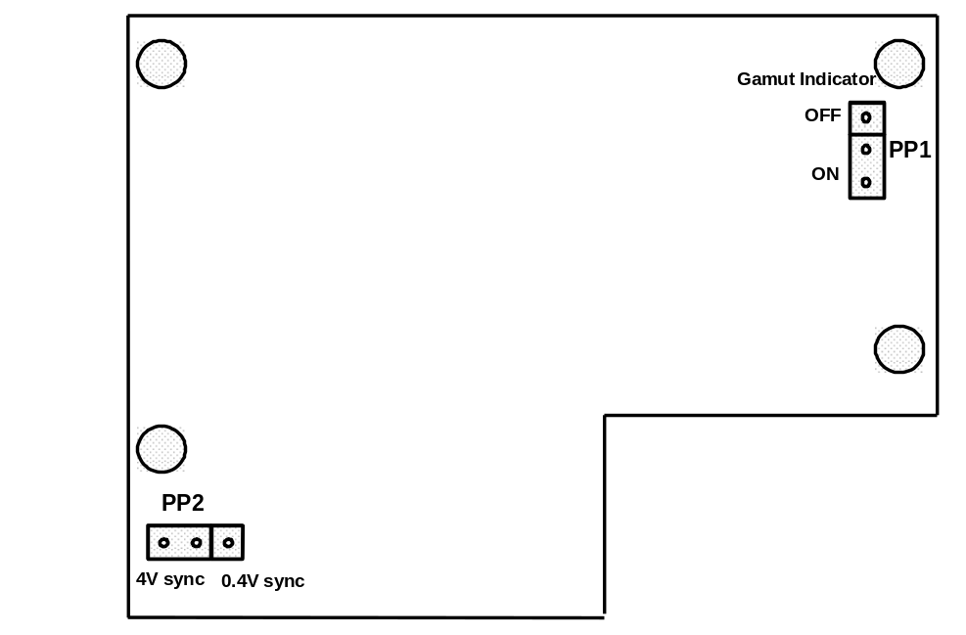

Fig 5-2 Location of jumpers

Rack mounting
This instrument is delivered either in a 19” cabinet or without cabinet for mounting in other compatible enclosures. In table top use, the free air convection is sufficient for cooling.
In systems where the instrument and other equipment are mounted in a 19” rack, special attention must be paid to the temperature. To avoid overheating, we recommend the following solutions:

Free air convection
Mount an air-flow unit (e.g. type PM 9799) between or underneath the cabinets. The dimensions of this unit is 1U high (=4.5 cm/1¾”) and 19” wide.

Forced circulation
Where forced convection is applied, f. inst. by ventilation fans in the top or bottom of the rack, care should be taken to have air flowing through the instrument.

Operating Instructions

Front panel controls
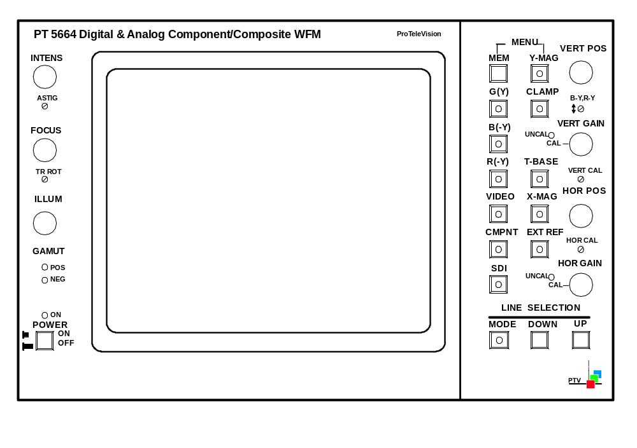
Fig. 6-1 Front of instrument

“POWER” – Mains switch
ON when pressed.
OFF when released (green band showing).
“ON”:
Pilot lamp indicates the ON state of the power instrument.
“ILLUM”
Continuously variable control of the graticule illumination.
“FOCUS”
Allows the beam to be focused for minimum spot size.
“INTENS”
Continuously variable control of the trace intensity.
“ASTIG”
Astigmatism control. Interacts with the FOCUS potentiometer.
“TR ROT” – Trace Rotation
Screwdriver control for aligning the trace in parallel with the horizontal graticule lines.
“GAMUT”
Gamut error detection.
POS LED goes on when the signal is above the legal RGB value +5% (735mV ±5mV).
NEG LED goes on when the signal is below the legal RGB value – 5% (-35mV ±5mV).
“MEM” – Memory
By pressing this button, it is possible to swop between two stored function set-ups.
For storing set-up, see Chapter 7, Item 7.11.
“MENU”
Pressing these two buttons (MEM & Y-MAG) simultaneously gives access to the main-menu and all sub-menus.
“G(Y)” – Green or Y component
With this button the G(Y) component can be switched on/off (analog or SDI)
“B(-Y)” – Blue or B-Y component
With this button the B(-Y) component can be switched on/off (analog or SDI).
“R(-Y)” – Red or R-Y component
With this button the R(-Y) component can be switched on/off (analog or SDI).
“VIDEO” – Composite video
With this button the composite video can be switched on/off.
If VIDEO is selected in Waveform mode when one or more component already are selected, the external video signal will be displayed with the “first” (Priority row: G(Y), B(-Y), R(-Y)) selected component signal overlaid. When VIDEO is switched off again, the monitor will return to the previous component selection.
If VIDEO is selected in Parade mode, the external video signal will be displayed in the left part of the display with the last selected component in the right part of the display.

“CMPNT” – Analog Component input
With this button the analog component input is selected. When this input is selected, the SDI Input is deselected.
“SDI” - SDI Input (Serial Digital).
With this button the Serial Digital Video (SDI) input is selected. When this input is selected, the CMPNT (analog component) input is deselected (i.e. G(Y), B(-Y) and R(-Y)).
“Y-MAG” – Vertical magnification.
When pressing this button the display will be magnified in the vertical direction. In Vector- and Star-mode this button simultaneously activates the horizontal magnification (X-MAG).
“CLAMP”
The switch selects clamp on/off. The clamp removes DC-content in the input without affecting hum. Depending on the display mode the button may not be operable, but the LED in the button indicates the actual status needed in the signal processing.
“T-BASE – Time base selector
With this button the up to 4 different time bases are selected: H, 2H, V, and 2V (i.e. 1 line, 2 lines, 1 field and 2 fields display). The number of time base steps depends on the selected mode.
“X-MAG” – Horizontal magnification.
When pressing this button the display will be magnified in the horizontal direction. In Vector- and Star-mode this button simultaneously activates the vertical magnification (Y-MAG).
“EXT REF” – External reference
When this function is selected (on), the signal applied to the EXT REF connector is used for synchronisation of the monitor.
When this function is de-selected (off), the sync of the displayed signal is used for synchronisation of the monitor.
“VERT POS” – Vertical beam position
Continuously variable control giving vertical shift of the display.
“B-Y, R-Y”
Level adjustment of the Blue/P_{B} and Red/P_{R} component.
“VERT GAIN” – Vertical gain
Continuously variable control of the vertical gain. When activated, the red LED “UNCAL” will be on.
“VERT CAL” – Vertical calibration
Screw driver adjustment of the vertical gain.
“HOR POS” – Horizontal beam position
Continuously variable control giving horizontal shift of the display.
“HOR CAL” – Horizontal calibration
Screw driver adjustment of the horizontal gain. In STAR, VECTOR and BOWTIE mode.
“HOR GAIN” – Horizontal gain
Continuously variable control of the horizontal gain. When activated, the red LED “UNCAL” will be on. In STAR, VECTOR and BOWTIE mode.
“LINE SELECTION”
MODE:
Activates the line selection mode, selection of Field 1, Field 2, both Fields, and de-activates the line selection mode.
DOWN/UP:
Line number selection. In Test mode VARIABLE the buttons DOWN/UP are used to select the variable set-up level.

Rear panel connections

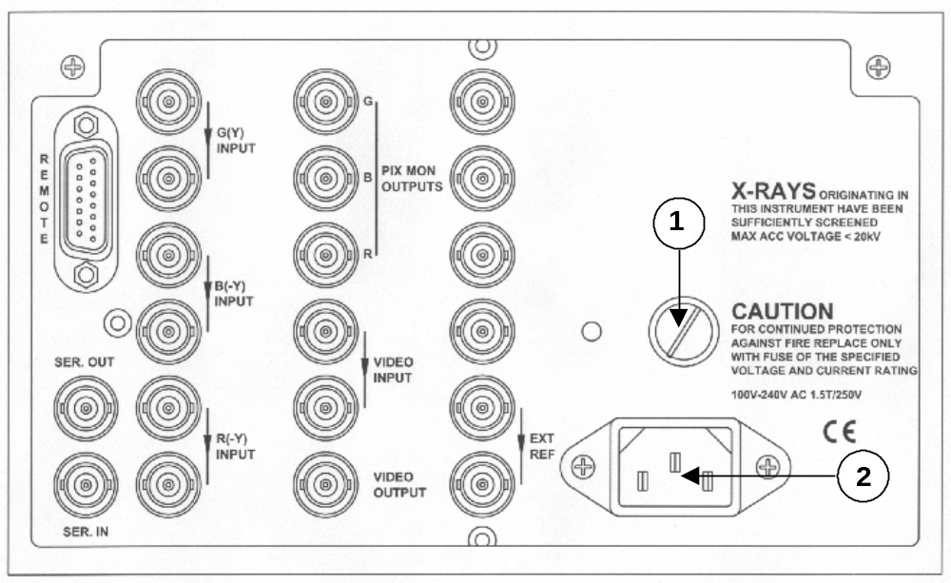

Fig 6-2 Rear panel

1
Mains fuse

2
Mains voltage input

“SER IN”
BNC for connecting the SDI signal. The input is internally terminated into 75Ω.
“SER OUT”
BNC supplying a buffered and re-clocked SDI signal of the “SER IN” signal.
“G(Y) INPUT”
BNC connector for connecting a Green or Y component signal. The input is loop-through connected and compensated for 75Ω. If the loop-through feature is not used, the unused connector must be terminated with 75Ω.
“B(-Y) INPUT”
BNC connector for connecting a Blue or B-Y component signal. The input is loop-through connected and compensated for 75Ω. If the loop-through feature is not used, the unused connector must be terminated with 75Ω.
“R(-Y) INPUT”
BNC connector for connecting a Red or R-Y component signal. The input is loop-through connected and compensated for 75Ω. If the loop-through feature is not used, the unused connector must be terminated with 75Ω.
“EXT REF”
BNC connector for connecting an external video or sync signal as reference. The input is loop-through connected and compensated for 75Ω. If the loop-through feature is not used, the unused connector must be terminated with 75Ω.
“REMOTE”
15 pin connector for TTL-controlled operation of 7 set-up memories.
The pin configuration is as follows:
Pin 1: Internal I²C-bus (SDA).
Pin 2: Internal I²C-bus (SCL).
Pin 3: MEM R-7.
Pin 4: Not connected.
Pin 5: MEM R-5.
Pin 6: MEM R-3.
Pin 7: MEM R-1.
Pin 8: Not connected.
Pin 9: Ground.
Pin 10: Not connected.
Pin 11: Store.
Pin 12: MEM R-6.
Pin 13: MEM R-4.
Pin 14: MEM R-2.
Pin 15: Not connected.
“PIX MON OUTPUTS”
The PIX monitor outputs always supplies the component signals in RGB format, also when the input signal is in color difference formats , i.e. YP_{B}P_{R}.
If RGB is applied as input format, the mounted transcoder is by-passed. Output is for monitoring purpose with 75Ω outputs.

“VIDEO INPUT”
Loop-through BNC connector for connecting a video signal. If the loop-through feature is not used, the unused connector must be terminated with 75Ω.

“VIDEO OUTPUT”
BNC connector applying the signal connected to VIDEO INPUT.

Main MENU (MODE) selection
To enter the MODE MENU, the push buttons MEM and Y-MAG (MENU) have to be pressed once simultaneously. The display will look as shown on figure 6-3 with the selected function "high lighted" by the arrow. At the same time the LED's in the relevant push buttons, below the MEM button, will light up, indicating which buttons can be used for the selection.

Now the display MODE in question can be selected by simply pressing the relevant button. If no selection is made the monitor will return to the previous mode after approximate 10 seconds. If no selection is wanted, the display can be left by selecting the MODE already indicated.

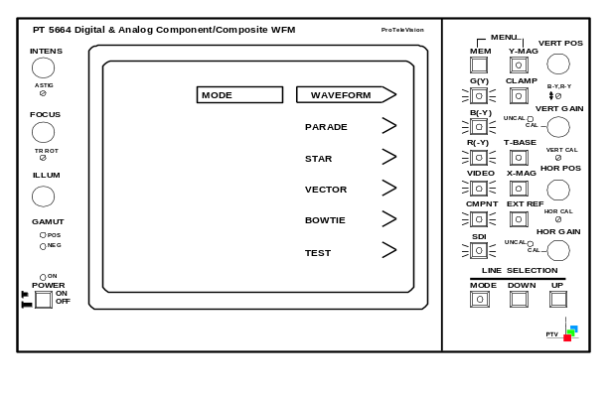

Fig. 6-3 MODE display

Input format
In the WAVEFORM, PARADE, STAR, and VECTOR mode it is possible to select the input format for the analog component signal.
Select the MODE menu and press the MEM and Y-MAG button simultaneously twice. Now the INPUT FORMAT mode enters the display (e.g. in figure 6-4).

Now it is possible to select between RGB input and Y/P_{B}/P_{R}, MII or Betacam depending on the instrument set-up.

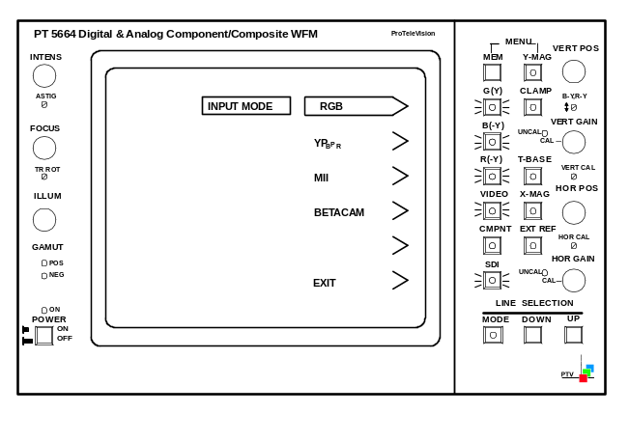

Fig. 6-4 INPUT FORMAT display

WAVEFORM display mode
The following modes can be displayed in the waveform mode:
- 1 line
- 2 lines
- 1 field
- 2 fields
These modes are selected on T-BASE button.

After the selection of “SDI” or “CMPNT” input, the component signal elements (or video signal) which is wanted for display must be selected on the G(Y), B(-Y), R(-Y), or VIDEO button. If 2 or more signals are selected they will be shown as overlaid signals.

Furthermore is possible to have a display of one single line in a frame (see section 6.10).

In the WAVEFORM mode it is possible to switch between different filters:
- “LOW PASS” - low-pass filter removes the high frequency video (or noise)
- “NON LIN” – band-pass filter used in measuring Static non-linearity (differentiating the steps of the staircase). The non-linearity measurement can only be activated when Waveform mode, Parade mode, Test-700mV mode, or Test-Variable mode is selected
- “FLAT” – no filtering is employed
The filter menu is entered by entering the MODE MENU, and pressing the MEM and Y-MAG buttons simultaneously one more time. The display will now look as figure 6-5.

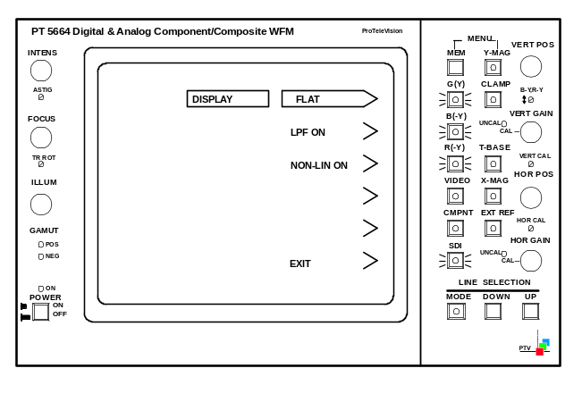

Fig. 6-5 DISPLAY mode

WFM Display format
In the WAVEFORM and PARADE display it is possible to select the actual display format. Analog YP_{B}P_{R} input or SDI input can beside their native format also be display as RGB. This function is valuable in monitoring of cameras, graphic editing. It shows immediately if colour gamut has been violated.

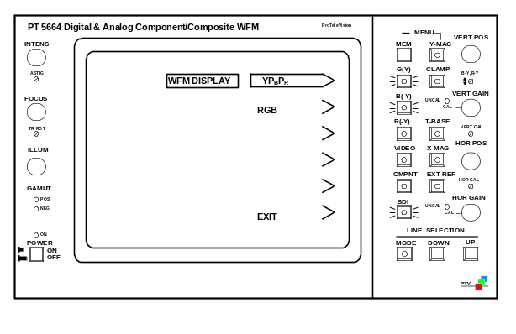

FIG 6-6 WFM display setting

PARADE display mode
The PARADE display mode offers 2 different displays:
- All three inputs side by side in the same display in the sequence left to right.
- R,G,B for RGB input signal or when dispæay format for SDI and CMPNT is selected as
RGB
- Y,P_{B},P_{R} for direct display of SDI input and analog colour difference signals
- Video input in the left part of the screen and a selcted component in the right part of the screen

The rest of the operation is identical to the waveform mode.

The colour difference components are clamped to the 50% level in the luminance/colour difference display mode.

STAR display mode
The Star display offers monitoring of timing and amplitude errors between the components of the RGB-signal, the Y/P_{B}/P_{R} or the SDI signal. The test uses an ordinary colourbar as reference signal, which reveals error with a good resolution.

Several sub-menus are available for the STAR display mode.
Pressing the MEM and Y-MAG buttons simultaneous twice will give access to the GRATICULE selection mode as shown in fig. 6-7.

Here it is possible to select the electronic graticule for either 75% or 100% colorbar, or switch off the electronic graticule with boxes of ±2% in size.
Furthermore it is possible to switch on/off (the function toggles) the small measuring dots used for checking timing errors. The measurement dots indicate 40, 80 and 160 ns of timing differences.

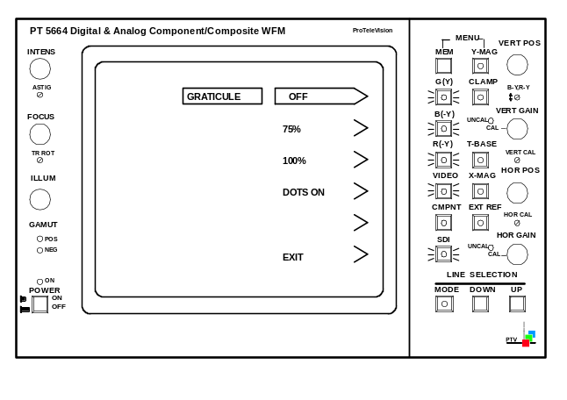

Fig. 6-7 GRATICULE selection display, Star mode

Component based signals from sources such as a VTR or camera are particularly sensitive to timing and amplitude errors in the signal path. A timing error results in coloured edges and an amplitude error results in discolouring of the picture. The STAR display in magnified mode is designed especially for the reveal of such errors. To ensure a correct alignment, the measuring dots can be switched on, to check for timing errors. (See fig. 6-8 and 6-9).

Every component can be switched off in case only two components have to be compared.

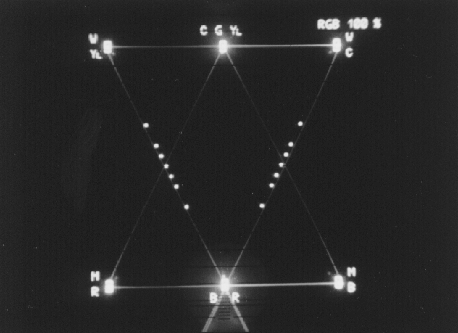

Fig. 6-8 Measuring dots, RGB mode

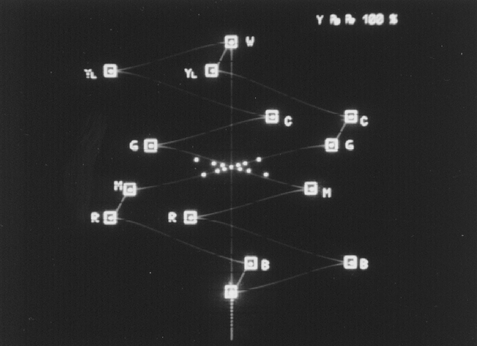

Fig. 6-9 Measuring dots, Y/P_{B}/P_{R} mode

Transcoder display
If the input format is RGB it is possible to switch on a transcoder. Select the MODE menu and press the MEM and Y-MAG buttons three times more. The TRANSCODER selection menu will be shown on the display (e.g. in figure 6-10).

With the transcoder on, the RGB input signals will be transcoded and shown as Y/P_{B}/P_{R}.

Note that with the transcoder on, the precision of the timing measurements will be slightly less accurate as without.

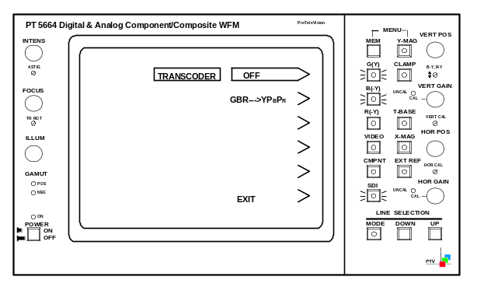

Fig. 6-10 TRANSCODER selection display

VECTOR display mode
The VECTOR mode shows the colour amplitude and phases of the incoming component signals.

When using the VECTOR mode, an electronic graticule for either a 75% or a 100% colourbar can be switched on. Pressing the MEM and Y-MAG buttons simultaneous twice will give access to the GRATICULE selection mode as shown in fig. 6-11.

Here it is possible to select the electronic graticule for either 75% or 100% colourbar, or switch off the electronic graticule.
Furthermore is possible to display a single line in a frame (See section 6.10).

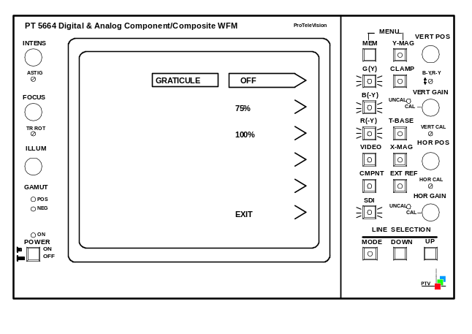

Fig. 6-11 GRATICULE selection display, Vector mode

Transcoder display
As in the Star mode it is possible to switch on a transcoder if the input format is RGB. For further menu operation see section 6.6.1.

TEST GRID facilities
When selecting the GRATICULE selection menu it is possible to select a TEST GRID function. This function offers three different test facilities.

NOTE:
To achieve a useable display, the intensity of the INPUT signal (INTENS) should be turned down fully.

- Beam accuracy check (see figure 6-12).
The shown square (largest one) contains four horizontal lines representing each a level. The lower line represents a level of -30%, the next line equals to 0%, the third line from the bottom represents a level of 40% and the upper line represents a level of 110%. These four lines should match with the same level marks on graticule of the CRT, to ensure that the signal level is displayed correct. A vertical off-set of ±4% can be tolerated.

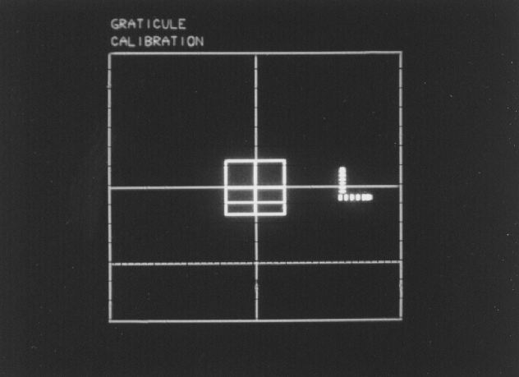

Fig. 6-12 Test grid, beam accuracy check

- X/Y-magnification check (see figure 6-13).
To check whether the magnification is within the legal limits, the Y-MAG or X-MAG button has to be pressed. Now it is possible to match the two squares using the VERT POS and HOR POS potentiometers on the front panel. The size of the two "squares" should be identical, with one beam width as maximum tolerance

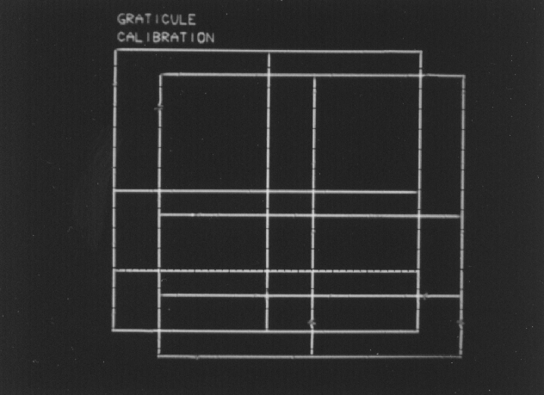

Fig. 6-13 Test grid, X/Y-magnification check

- D/A-converter check (see figure 6-14).
To check whether the D/A-converter is converting correctly, the Y-MAG or X-MAG button has to be pressed. By moving the horizontal position to the left, a horizontal and vertical "arrow" will appear on the display. Each arrow consists of six small waves, which represent the six lowest bits in the horizontal and the vertical direction. The magnitude of each wave should be twice the size of the previous wave (starting from the lower left). The vertical and horizontal waves in the same "bit"-position should be identical in magnitude.

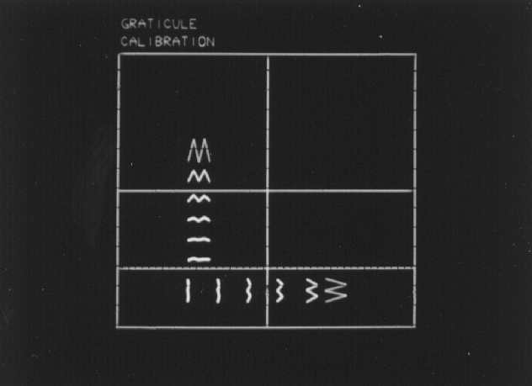

Fig. 6-14 Test grid, D/A-converter check

BOWTIE display mode
The BOWTIE mode is used to align studio systems for amplitude and timing. For this a special test signal is needed, which then will indicate the relative amplitudes and relative timing on the monitor. The test signals applied are a 500kHz sinewave signal applied to the G(Y)-input and a 502kHz sinewave signal applied to the R(-Y)-input and the B(-Y)-input. The monitor makes a subtraction and shows in the left part of the display G(Y)-B(-Y), and G(Y)-R(-Y) in the right part of the display.

The 502kHz signal, applied at the B(-Y)- and R(-Y)-inputs, is generated in a way, so that it is in phase with the 500kHz signal, applied at the G(Y)-input, in the centre of the signal.
Equal amplitude is therefore obtained when the centre of the "butterfly" is zero (see figure 6-15). Amplitude errors will be seen as a raise of the centre-point.
Correct timing is obtained when the centre of the "butterfly" is located at the tallest "marker pin" (see figure 6-15). Timing errors can be measured directly since each "marker pin" corresponds to a timing interval of 20 nanoseconds.

X- and Y-magnification can be operated in the BOWTIE mode to increase the precision of the measurements.

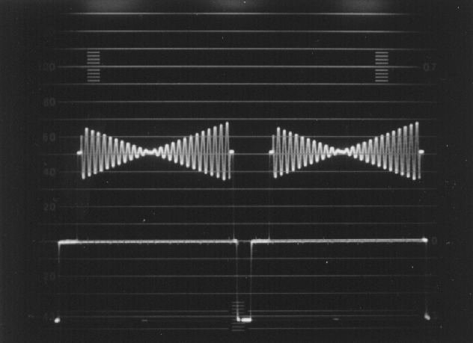

Fig. 6-15 BOWTIE signal

TEST mode
In TEST mode the PT 5664 offers several facilities for calibration purpose. A survey is found in the CALIBRATE menu. This menu is automatically obtained when TEST is selected in the MODE menu.

NOTE:
When selecting a test facility, the monitor will remain in this mode until another mode is selected in the MODE menu.

Following test facilities are available:
- 700mV
This function shows a steady indication of the 700mV level. This function shows the incoming video signal twice:
- As normal waveform display and
- As an overlaid signal with 700mV off-set.
The 0-line of the off-set signal indicates the 700mV level. The V/2V function can not be operated in this mode.

- VARIABLE
Indicates a selected level on the display. This function shows the incoming video signal twice:
- As normal waveform display and
- As an overlaid signal with variable off-set.
The off-set can be selected by means of the UP and DOWN buttons in the Line selection part on the front panel. The off-set can be varied from -500mV to +1500mV. The 0-line level of the overlaid (off-set) signal is shown in mV in the upper left corner of the screen.

- 100kHz
To check the horizontal timing and the vertical deflection in Waveform mode, a 100 kHz square wave signal with an amplitude of 1V_{PP} is provided from an internal generator.

- G(Y) & EXT ALT
This mode offers a waveform display of the G(Y) component signal alternating with the external reference signal. This gives the possibility to check the timing between the two signals. Note that the signals has to locked together and timing difference not greater than one line.

- G(Y) – EXT
This mode offers a waveform display of the subtraction between the G(Y) component and the external reference signal. The feature offers the possibility to check the timing between the two signals. Note that the signals has to locked together and timing difference not greater than one line.

- EXT
Shows the signal applied at the EXTERNAL REF connector.

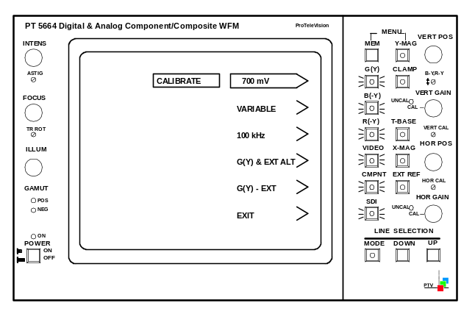

Fig. 6-16 TEST mode sub-menu

Line selection

General
In the WAVEFORM and the VECTOR mode it is possible to select display of a single line of the signal.

The line selector function is activated by pressing the MODE button once. The selected line- (and field-) number is shown in the upper left corner of the display.
A second press on the MODE button will make the instrument switch to the equivalent line in field 2.
A third press on the mode button will make the instrument show the equivalent lines of both field 1 and 2 at the same time.
A fourth press on the MODE button will switch off the line selection mode again.

The wanted line number can be found by pressing the UP or DOWN buttons. One push selects the next line. Continuous pressing of the UP or DOWN button will activate a scroll function

If the UP or DOWN button are pressed and the next line number in question will exceed the relevant line numbers of the field, the monitor automatically switches to the other field.

Please pay attention to the following notes:
- The line selection function can only be activated in the WAVEFORM and the VECTOR mode.

- If the TV system applied to the monitor is a non-interlaced system (e.g. 524 lines or 624 lines), it will be indicated by "NI" after of the line number when line selection mode is activated, and the field that is selected as field 1 is random.

- Correct function of the line counter in single line mode can only be guaranteed when either sync is applied on the incoming signal or an external reference is applied.

- In case the TV system applied to the monitor (e.g. 625 lines to 525 lines) is changed without turning the monitor off, one of the three buttons in the line selection part (MODE, UP, or DOWN) must be pressed once to obtain correct operation of the line counter.

Waveform mode
As mentioned earlier the WAVEFORM mode can offer display in:
- 1 line
- 2 line
- 1 field
- 2 field-mode.

When a 2-line display is selected the "left line" is the one which is indicated in the upper left corner.
When the 1- or 2 field function is selected, the selected line(s) will be highlighted on the signal display.
The line-number indication in the upper left corner of the display is not activated when the 2-field (2V) function is selected or if both lines are selected in the 1-field (V) display.

Please note that only one component (or the video input signal) can be shown at the time when the line selection mode is activated.

Vector mode
In the VECTOR mode only two components (B(-Y), R(-Y)) can be shown (at the same time).

Gamut error detection
Monitoring of the Gamut range ensures that no illegal colour can occur without a warning is released. A Gamut error occurs when a primary colour component level exceeds the limits of 735mV in the upper range and -35mV in the lower range. This error is made visible by two LEDs on the front panel of the instrument, and on the PIX MON OUTPUTS as a flickering area on the monitor screen displaying the error area.
To avoid extremely short transients to trigger to gamut detection a low-pass filter is inserted. This filter has a bandwidth of approximately 1 MHz.

NOTE:
The PT 5664 is supplied with the Gamut error indication on the PIX Monitor outputs on.

Master reset of the PT 5664
In case some electrical interruptions make it impossible to operate the instrument or the set-up is to be changed fully, a master reset function is available.
Reset is performed as follows:
- Switch the instrument off
- Keep the R(-Y) button pressed and switch the instrument on

After the reset the instrument will return to the following default set-up:

General:
- SDI input selected
- Clamp on
- G(Y) selected
- LP-filter off
- Y/P_{B}/P_{R}-format selected
- Internal sync

WAVEFORM mode:
- 2 H

PARADE mode:
- 2 H

STAR mode:
- 75% graticule
- Dots off

VECTOR mode:
- 75% graticule

TEST mode:
- Variable test voltage: 0 mV

Furthermore is WAVEFORM mode selected as MEM 1 and VECTOR mode selected as MEM 2.

NOTE:
The set-up of the remote controlled MEM-functions will not be reset.

Memory functions
The PT 5664 is equipped with two set-up memories available from the front panel controls, and with 7 set-up memories available from the REMOTE connector.

Front panel controlled memories
Two different front panel set-up's may be stored in each a memory (MEM 1 and MEM 2), controlled via the MEM button on the front panel. The monitor toggles between the two memories when the MEM button is pressed.

NOTE:
Only main modes are stored, not the settings of f. inst. low-pass filter, modification to displays, etc.

Storing a set-up:
- Select with the MEM button the memory in which a new set-up shall be stored
- Select the mode and set-up you want to store
- Press the two buttons MEM and Y-MAG (MENU) simultaneously
- Press the button for the selected mode (indicated by the arrow) and the MEM button simultaneously. The selected mode and set-up is now stored

NOTE:
The position of the potentiometers can not be stored.

Remote controlled memories
The PT 5664 is equipped with a TTL remote control which gives access to other 7 memories. Each memory is recalled when the appropriate pin on the REMOTE connector is (shortly) connected to ground.

For pin configuration of the REMOTE connector please see section 6.2 Rear panel connections

Storing a set-up:
- Select on the front panel the mode and set-up you want to store
- Connect pin 11 (Store) to ground (pin 9)
- Connect the pin in question for the selected memory shortly to ground
- Disconnect the ground from pin 11 (Store). The selected mode and set-up is now stored

Service and Maintenance
The PT 5664 consists of 8 (10) units.
These are:
Power Supply Unit 1
CRT Board Unit 1A
Illumination Panel Unit 1B
CRT Control Unit 2
Deflection Amplifiers Unit 3
Signal Processor Unit 4
Potentiometer Board Unit 5
Keyboard Unit 6
SDI input and Control Unit Unit 7
RGB Monitor Out Unit 8

Main functions of the units

Power Supply
The Power Supply delivers various regulated and unregulated voltages used by other parts of the instrument. Also supplies the CRT with the necessary voltages like FOCUS, High Tension, and filament voltage.

CRT Control
The CRT Control unit contains 6 potentiometers used to control Intensity, Astigmatism, Focus, Trace Rotation, and Illumination.

Deflection Amplifiers
This unit contains amplifiers, which amplify the horizontal and vertical signals to the proper level with respect to the deflection plates of the CRT.

Signal Processor
The three analog component signals from the input connectors are fed, each via a different amplifier, to the Input Switch selecting between the analog input signal and the SDI-to-analog converted signal.
The selected signal is next fed to the Monitor matrix, the Display matrix, and the RGB Display switch. The output of the RGB Display switch is fed to the Format Switch, the Reference Switch and the H- and V-selector

If the input signals are in RGB mode, they are fed directly via the Format switch to the output buffers on unit 8. If the input signals are in YUV mode, they are converted into RGB mode by the Monitor matrix circuit.

The Display matrix works the opposite way. If the input signals are in YUV mode, there are two display modes:
- Presentation of signals in YUV, when signals are fed directly to the V- and H-selectors.
- Presentation of signals in RGB in waveform and parade, when signals are directed from the output of the Monitor Matrix to the RGB Display switch, which feeds the V- and H-selectors.
If the input signals are in RGB mode, they are converted into YUV mode by the Display matrix circuit.

The Vertical Selector circuit selects the input for the Variable Gain circuit. The selected signal can be fed through the band-pass section of the Non-Linearity filter (selectable in menu in the display), the function of which is to remove chroma information and differentiate the luminance steps. The variable gain amplifier is controlled by the VERT GAIN potentiometer on the front panel. The graticule generator in the two TEST modes also adds a “reference” signal here.

From the Variable Gain Amplifier the signal is fed to a polarity switch, which may invert the signal. Only the non-inverting is used in standards instruments. Then a clamp is applied to the vertical signal (if selected). This clamp pulse provides also the clamp of the U and V component to the 50% level in YUV parade mode. The vertical signal is then fed either via the second part of the Non-Linearity filter (low-pass) or, if selected, through the Vertical Low-Pass filter (4th order filter). The filter switch is used to select one of these two filters.

The input signal to the vertical drive amplifier comes either from the Filter switch, the Graticule Generator (VGV), or in Bowtie mode via the H-SIGNAL switch. A DC voltage from the VERT POS potentiometer has also been added. The gain of the Vertical Drive amplifier depends on whether the instrument is in The Normal mode or Y-MAG (x5) has been selected. The vertical deflection signal is then fed via the Vertical Output Amplifier on unit 3 to the CRT.

The signal selected with the Horizontal selector is fed through a Variable Gain amplifier, a Polarity switch, and a Low-Pass filter, all similar to the circuits in the vertical signal path. In the buffer, which comes after the Low-Pass filter DC voltage from the HOR POS, potentiometer is added to the signal. This signal is used for horizontal deflection when the Vector or Star mode has been selected (X/Y-mode). If one of the waveform modes is selected, a sawtooth signal from the sawtooth generator is used. A horizontal line time pulse is used as clockpulse for the Sawtooth Generator. This is derived from the Sync Separator circuit via the Clamp Generator. The Sync Separator also contains an oscillator, which provides a line "substitution" signal in case no external sync is provided. The Sawtooth Generator generates 6 different ramp signals depending on the selected display mode (V, 2V, H, 2H, Parade-H, Parade-V). The signal selection switch is controlled by the microprocessor (Unit 7).

The input signal to the Horizontal Drive Amplifier is comes either from the signal selection switch or from the Graticule Generator (HVG). The gain of the Horizontal Drive Amplifier depends on whether the instrument is in normal mode or X-MAG (x5) has been selected. The horizontal deflection signal is then fed via the Horizontal Output Amplifier (Unit 3) to the CRT.

Finally, unit 4 contains a Calibration Generator, which provides a 100kHz used in TEST mode to check the horizontal timing and vertical deflection. This signal is fed to the V-selector circuit, while a 12.5kHz signal derived from the 100kHz signal is fed to the Sync Separator as a horizontal timing pulse.

Potentiometer Board
The Potentiometer Board houses the potentiometers for adjustment of the horizontal and vertical gain, horizontal and vertical position, X- and Y-gain, and the position of the B-Y and R-Y signals in the PARADE display mode.

Keyboard
The Keyboard contains all the selectors on the front panel. The output of the keyboard is input to the Unit 7 Control Board.

SDI and Control Board
The SDI and control board contains the processing of the digital SDI input signal. The SDI signal on the input connector is equalised and fed to an active SDI output amplifier and to the De-serialiser. Next, the signal is demultiplexed into 3 data streams and fed to a D/A converter with postfiltering.

The board also contains a microcontroller to control the function of the instrument, an electronic graticule generator. The microcontroller provides various control signals to the other parts of the instrument, either by use of an I²C bus or an 8-bit parallel databus line (for unit 4). Input to the microcontroller is line and field information, the keyboard, and the remote connector.

The Electronic Graticule Generator provides the electronic graticule and the menu text on the CRT display.

RGB Monitor Out
This unit contains the RGB video output buffers with clamp drivers for the PIX MONITOR Output’s, an amplifier for the external reference signal, a composite video amplifier for the monitor out, and a gamut detector.
The gamut detector determines whether the level of a primary colour component exceeds 735mV (±5mV), or -35mV (±5mV): If it does, this will be indicated on the GAMUT LED’s and on the PIX MON OUTPUTS as a flickering area on the monitor screen displaying the error area.

Access to units
General information
For the location of connectors on the various units, please see Figs. ?? and ??? (wiring diagrams).

Removing the Cover
- Remove the PT 5664 cover by unscrewing two screws "A" at the rear panel (see fig. 6-2)
- Pull the instrument out of the cover

Access to and Removal of the Signal Processor (Unit 4) and SDI and Control Board (unit 7)
Access to the solder side of Unit 4:
- Remove flat cable connectors "C", "D", and "E" at the rear of Unit 4

Fig. 7-1 View of connectors - photo

- Remove the screw "B" on the rear panel. Care-fully pull the Signal board and the CPU unit out from the front of the instrument

Fig. 7-2 Slide-out units. Photo

- Access to the component side of the Signal board and the CPU unit is obtained by unscrewing the three screws "F" and open the two units carefully

Fig. 7-3 Screws on CPU unit. –Photo

Access to and Removal of the Power Supply - Unit 1
- Turn the PT 5664 upside-down
- Remove three screws "G" and lift the Power Supply unit out carefully
- To get access to the solder side, the 10 screws holding the PCB onto the plate underneath must be removed

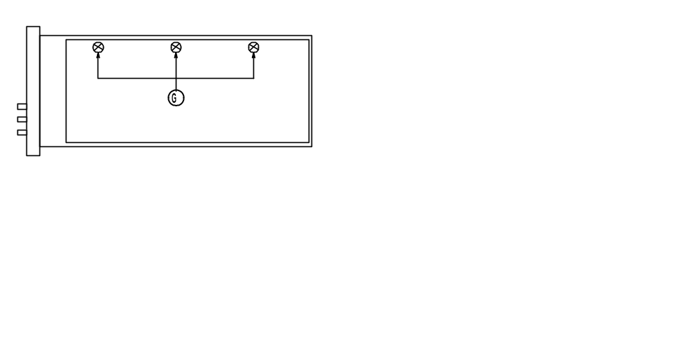

Fig. 7-4 Power Supply unit

Access to and Removal of the CRT Control Unit - Unit 2
- Remove the three knobs "H" (see fig. ????)
- Remove the "upper" hexagonal screw which holds the PCB onto the frame of the instrument
- Remove Unit 1 as described in paragraph 3.3
- Remove the "lower" hexagonal screw which holds the PCB onto the frame of the instrument
- Pull out the unit

Fig. 7-5 Front of instrument. – Photo

Access to the Deflection Amplifier - Unit 3
- Remove the plugs on connectors XE, XP, and XJ (see fig. ????)
- Remove the unit by unscrewing the four screws holding the PCB onto the frame of the instrument

Access to the Potentiometer Board - Unit 5 and the Keyboard -
Unit 6
- Remove the Signal Board as described in section 3.2
- Remove the plug on connector XP on the Key-board panel
- Remove the two screws "M"

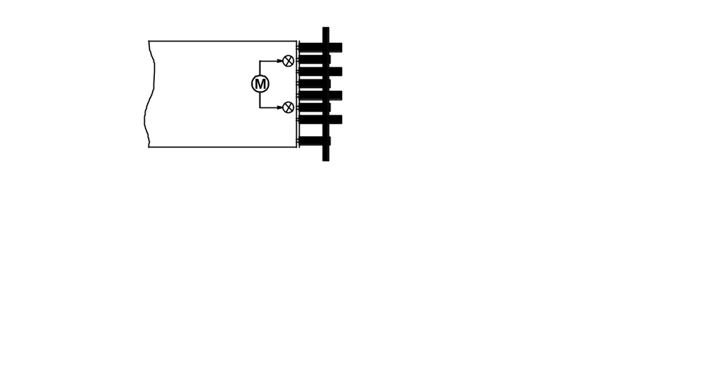
Fig. 7-6 Signal board, solder side

- Remove the plug on connector XN on the Signal Board
- For full access to the Keyboard, remove the 4 knobs marked "I" in Fig. 3-6 and the two screws marked "O" in fig. 7-7

Fig. 7-7 Keyboard, solder side. – photo

Access to the RGB Monitor Out Unit - Unit 8
- Remove the plug on connector XK on Unit 8
- Remove the unit by unscrewing the four screws holding the PCB onto the frame of the instrument

CRT Replacement
- Remove the window marked "K" and the grey filter marked "L" in fig. 7-5
- Remove the plug from the connector on the Illumination panel
- Disconnect the Power Supply as mentioned in section 7.2.3
- Remove the H.T. supply socket mounted on the anode of the CRT
- Discharge the anode on the CRT
- Remove the plug from connector XE on the Deflection amplifier unit
- Remove the plugs from connectors XG, XE, and XH on the CRT board
- Remove the CRT board
- Pull off the ground connection wire on the shielding
- Unsolder the wire yellow and the red wire coming from the trace rotation coil on the Illumination panel (ST 1 and ST 2) (see fig. 7-8)

Fig. 7-8 Wiring Illumination panel - tegning

- Pull out the Illumination panel
- Remove the plug on connector XP on the Deflection amplifier unit
- Release four screws "P" holding the fixing plate in position in respect to the CRT

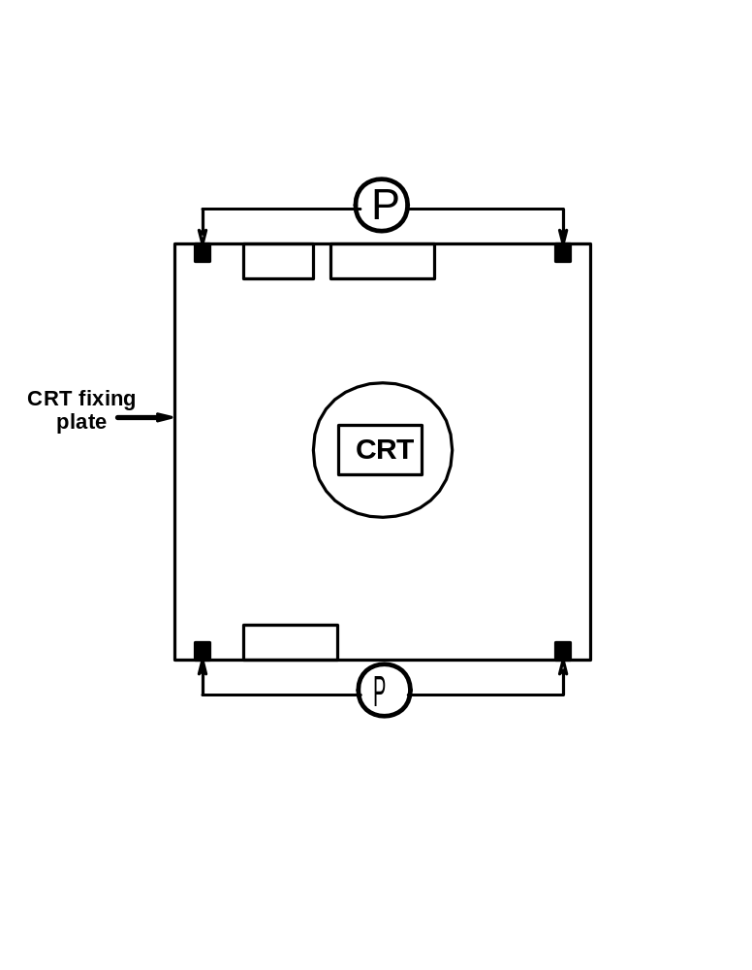
Fig. 7-9 CRT fixing plate

- Pull out towards the back and then flip out from the bottom the CRT-including shielding and rubber bushing towards the bottom
- Pull the shielding off the CRT

Fig. 7-10 CRT Removal. – photo

Power Supply - Unit 1

General Information
The Power Supply provides various regulated and unregulated voltages used by other parts of the instrument. The instrument may be powered by a mains voltage of 85-240V AC_{RMS}, 120-264V DC. The mains voltage primary is protected by a 1.5A (slow) fuse (F1) located at the rear of the instrument.

Circuit Description

Mains Rectifier
The mains voltage is rectified by the diode bridge (D1). The DC voltage is then smoothed by the choke L1, and capacitors C2 and C3. The DC voltage is then fed into the Converter circuit, which consists of a Switch controller, Converter switch, and dV/dt limiter.

Converter Circuit
The flyback converter consists of transistors Q2 and Q3 and their associated components. The converter frequency depends on the input voltage. For 110V AC it is approx. 35kHz and for 220V AC approx. 50kHz. These frequencies may vary, since the frequency also depends on the load connected to the power supply.

Transistors Q2 and Q3 conduct on the forward stroke and feed the current into pin 3-4 of T1. The voltage at R15-R16 increases with the current of T1. When the voltage at R13 exceeds approx.0.7V it will fire switch D11, which when switches Q2-Q3 off. The energy in T1 will during flyback time induce a voltage at the secondary windings, which will be rectified and fed into the DC output capacitors. Also during flyback time, a voltage will be induced at pin 1-2 of T1. This voltage will recharge capacitor C4 via the path D10, D9, Q1, R6/R8, C4, and L2. When a certain value is reached, D11 is switched off. Q2-Q3 is then switched on and the sequence starts all over again. The signal at the gate of Q2 is a square wave signal received from the Voltage Stabiliser. The dV/dt limiter (L4, C12 and D14) serves to eliminate the switching spikes at the collector of Q3.

R3 is used to start up the power supply when the instrument is first switched on.

DC Output
The DC Output circuit rectifies the signal from T1. The DC voltages are smoothed by the capacitors. The +12V and -12V are regulated by V4 and V5. DC voltages for use in other parts of the instrument come from this circuit.

Voltage Control - Reference
The Voltage Reference circuit ensures an accurate 10V reference to the Voltage Control. The Voltage Control compares the reference voltage with the -15V output. If there is a change in the -15V supply (e.g. due to increasing load at any output) the output of V1-B will correct the output via the opto-coupler and bring DC levels back to normal.

Optocoupler
The current through R7 is determined by the Optocoupler, this current also runs through R13. Together with the current from R14 they determine the intervals at which switch D11 is fired. When the output from the Power Supply decreases (e.g. due to increasing load) the current through R7 will decrease. The intervals at which D11 fires will be longer due to the smaller current contribution from R7. The energy in T1 will then increase and the output voltage will return to normal.

Voltage Protection
The Protection circuit is used to protect the Power Supply against too-low or too-high voltages at the outputs. With too high an output voltage at the +15V output, Q5 will switch on. D29 in the ±43V output will turn on and short-circuit the outputs. If one of the outputs short-circuits, the power supply will operate at a low frequency (approximately 2kHz). When the output voltages are too low, Q4-Q6 will also switch on D29 and short-circuit the output. R40/C21 ensures that a virtual short circuit of the output is ignored when the instrument is first switched on.

High Voltage Generator - Tripler
The output from the oscillator (Q8-Q9) is transformed by T2 and fed to the tripler. The frequency is controlled by T2 (approx. 65kHz). The amplitude is controlled by the output from V3-a via Q7. The control circuit receives a feedback (-2k6V) from the output and the reference voltage from V1-A. The H.T. supply also supplies the CRT with filament voltage. -2.6kV is fed to the Black Level circuit and the AC/DC converter on the CRT Board. The tripler supplies the CRT anode with +14kV.

Trace Rotation
The Trace Rotation circuit (Q10-Q11) determines the strength and direction of the current passed to the trace rotation coil wound around the neck of the CRT. The current is controlled by a front panel screwdriver operated potentiometer control.

Illumination Control
The Illumination circuit (V3-B, Q14) determines the amount of current passed to the Graticule Illumination lamps (LA1-3) of the CRT, and the amount of current is controlled by the ILLUM potentiometer on the front panel. Q13 controls whether the Illumination lamps are on or off.

Z-Amplifier
The intensity of the beam is controlled by the Z-Amplifier. An oscillator signal (Z-OSC), which controls the intensity, is led from the High-Voltage Generator to a limiter - circuit (Intensity - LF), which controls the peak-peak amplitude of the oscillator signal, depending on the setting of the intensity potentiometers.

The different modes (Vector, Waveform, Test, etc.) need different light - intensities at the same potentiometer setting. This is controlled by the analog switches V7, which connects different resistor values to the emitter of Q20 depending on the selected mode. and V8, which shifts, depending on the selected mode, between the MENU, INTENS, and ILLUM potentiometer to control the voltage at the base of Q20. The analog switches are con-trolled by three inputs (I0, I1, and I2) derived from the Signal Processor (Unit 4). These three lines make up the set-up shown in table ???

AC/DC Converter (Unit 1A)
The AC/DC converters (D43-D44) convert the oscillator signal a DC voltage, which is fed to G1 on the CRT and thereby controls the intensity on the screen. The blanking pulses from the Z-Amplifier are fed directly to the AC/DC converter via C78. The negative pulses will switch off the beam.

Black Level (Unit 1A)
The black level circuit is used to ensure that the beam is switched off when the INTENS potentiometer is in minimum position. This is adjustable by means of R4 (use a trimmer with an isolated tip). Q1 determine the minimum current through transistors Q2-Q4 and thus the voltage on the cathode of the CRT.

Focus Voltage Conversion
This circuit produces the focus voltage required by the CRT. The FOCUS potentiometer and the current through R107 determine the current through transistors Q2, Q3, and Q4 and thus the G3 focus voltage to the CRT. When the intensity on the screen changes, the focus voltage must change too. To ensure stable focus, the output from the Z-Amplifier with information on the intensity is connected to the Focus circuit via the Dynamic Focus circuit.

I0 | I1 | I2 | Potentiometer (V8) | Resistor (V7) | Function (Mode)
0 | 0 | 0 | INTENS | R142 | Waveform
0 | 0 | 1 | INTENS | R143 | Waveform, single line
0 | 1 | 0 | R159/160 | R144 | Text, single line
0 | 1 | 1 | MENU | R145 | Menu text
1 | 0 | 0 | ILLUM | R146 | Text
1 | 0 | 1 | ILLUM | R147 | Graticule
1 | 1 | 0 | ILLUM | R148 | Dots
1 | 1 | 1 | MENU | None | Blanking

Equipment
- DVM
- High voltage probe
- Test signal generator PM5640
- Oscilloscope
- Component generator

Power supply (unit 1) and CRT-board unit (1A)

1. Reference voltage - R28.
- Connect a digital voltmeter to TP 7
- Adjust R28 to 14.8 V ±20mV

2. High voltage generator - R49.
- Connect a High voltage probe to connector XT pin 2
- Adjust R49 to 2540 V ±10V

CRT Control - Unit 2
The CRT Control unit consists of 6 potentiometers (of which 5 are accessible from the front of the instrument) and LED’s for ON and GAMUT indication. The potentiometers are used to control the Intensity, Astigmatism, Focus voltage of the CRT, Trace rotation, and the Illumination of the graticule light. The last potentiometer, which is not accessible from the front of the instrument, is used for adjustment of the MENU intensity.

Diode D1 reduces drift of the intensity.

Deflection Amplifiers - Unit 3

General Information
This unit contains the final amplifiers needed to supply the CRT plates with proper signal amplitudes.

Circuit Description

Horizontal Output Amplifier
The signal from the Unit 4 X-Driver enters the clipper circuit formed by the two double diodes D5 and D6, which limit the signal amplitude to approximately ±1V. Via gain control R17, the signal from the clipper enters the base of V1-b on the first differential amplifier V1-B/V1-C. V1-D controls the bias in the output stage, which at R23 is adjusted to approximately -14V at outputs XE5 and XE6 at 0V input. A balanced signal from the collectors of V1-B and V1-C is sent to the bases of Q1 and Q2, which together with Q3, Q4, Q5, and Q6 form a differential amplifier cascode-operated with its current source (Q5-Q6) at the collectors. The output is low-impedance due to the emitter output. R4/R19 and R12/R21 determine gain and D1-D4 functions as temperature compensation. D2 and D3 (LED’s) light up under normal operating conditions.

Due to minor deviations of the physical 90° relationship between the vertical and horizontal deflection plates of the CRT, it may be necessary to compensate by feeding a horizontal signal component to the Vertical amplifier, thereby eliminating the fault. Resistors R27-29, which feed this orthogonality signal to the Vertical Output amplifier, are only mounted in instruments, whose CRT needs this compensation.

Vertical Output Amplifier
The signal from the Unit 4 Y-Driver enters the clipper circuit formed by the two double diodes D9 and D10, which limit the amplitude of the signal to approximately ±1V. Via gain control R40, the signal from the clipper enters the base of Q43 of the first differential amplifier (Q42-Q43). The second differential amplifier consists of Q44 and Q45. Q41 and Q46 are current sources for these two differential amplifiers. A balanced signal from the collectors of Q44 and Q45 is fed to the two cascode-coupled output stages Q48-Q49 and Q50-Q51.
Q47 controls the bias in the output stage, which on R77 is adjusted so that the voltage on the output XE1 and XE2 is approximately 0V at 0V input. The frequency response of the amplifier can be adjusted at R72/C54. The DC offset at the two outputs XE1 and XE2 can be adjusted by changing the DC balance (R50) in the First Differential amplifier.

Signal Processor - Unit 4

General Information
This unit is the heart of the instrument because it is here all the signal processing is done. This unit contains circuits for Waveform, Vector, and Test; the signal paths through the circuits are controlled by the microprocessor on Unit 7. Furthermore the unit contains three looped-through inputs CH1, CH2 and CH3.

Circuit Description

Input Buffer and switches
Since the three input buffers CH1, CH2, and CH3 are identical, only CH1 is described.

The input buffer is constructed as a Non-Inverting amplifier with a gain of one. At the input of the amplifier is an AC/DC switch, (Q1). When 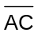 is high, Q1 short-circuits and the amplifier is DC-coupled.
From the AC/DC switch the signal enters the integrated video amplifier. At R7 it is possible to adjust the current so that the DC offset on the buffer output is zero.
he input switch V2 selects between the signal from the analog input buffer and the converted signal from the SDI interface on Unit 7. A second switch, which is based on two video amplifiers V12-A and V-12B, selects between the signal coming directly from the input switch and a processed signal from the MONITOR MATRIX. The video amplifiers are enable with the 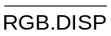 control. This function enables the display of YUV signals as RGB (Waveform and Parade only).

The output of the input switch V2 is buffered by V16 for the driving the two matrices: MONITOR MATRIX and DISPLAY MATRIX.

Calibration Generator
The calibration generator is built around the IC V5. This counter is provided with a 6.4MHz X-tal oscillator. The 6.4MHz signal is reduced to 100kHz (TEST) and to 12.5kHz for the sync separator.

Sync Separator
The sync separator is constructed as a small sub-unit comprised of SMD components and considered one single component.

The sync separator receives its input from multiplexer V6.

The following signals are available to the Sync Separator:
- CH1 (CVS low)
- Composite video (ERS low and CVS high)
- External sync signal (T-SEL, ERS and CVS high), and
- 12.5 kHz signal from the calibration generator (T-SEL low and ERS, CVS high)

Following signals are available from the Sync Separator:
- Composite sync (SYNC)
- A line-sequential sync (LINE)
- A field-sequential sync (FIELD), and
- A frame-sequential square-wave signal (FIELD1)

Monitor Matrix
The monitor matrix circuit converts the input signals from the input buffers from YUV mode into RGB mode. If the input signals are R, G, and B, the matrix is by-passed by means of the multiplexer V8.
The output from the monitor matrix is also used for displaying YUV signals as RGB in WAVEFORM and PARADE mode.

Display Matrix
The Display Matrix circuit converts the input signals from RGB mode into YUV mode. This is accomplished by a resistor array (R91) and the Operational amplifiers V9-A-C-D.

Vertical Selector
The Vertical Selector circuit selects the input to the Variable Gain circuit. The selected signal can be fed through the band-pass section of the Non- Linearity filter by means of the V206 switches (NON low).

Non-Linearity Filter
The Non-Linearity filter is divided into two parts:
- A band-pass section before the Variable Gain circuit and
- A low-pass section after it.
This is done to eliminate non-linearity errors deriving from the variable gain circuit.

The Non-Linearity filter, built up around the transistors Q214, Q215 and Q311, removes the chroma information and differentiates the luminance steps. The output from the filter is spikes expressing the amplitude of the luminance steps in the incoming video signal.

Variable Gain Vertical
The signal from the V-selector circuit is fed to the one part of a balanced input on the double-balanced modulator IC V202 (pin 4). It also enters the inverting amplifier Q211-Q213, which produces a balanced input for balanced modulator V202 (pin 1). The inverting amplifier has a gain of -1.0.

A "reference" signal, Vertical Graticule Variable (VGV), from the graticule generator can be added to the input signal via R270-R271 and V206-B. This is active in the two TEST modes in which you add a signal as reference (700mV or variable level).

The V-BAL potentiometer (R268) is adjusted so that the DC offset at the output of V202 is independent of the gain settings. The OFFSET ADJ. potentiometer is adjusted for minimum offset.

The gain of V202 can be controlled either by the V-CAL or the V-VAR GAIN potentiometer on the Potentiometer Board (Unit 5). When the V-VAR GAIN (VERT GAIN) is turned away from its left-most position, the "V-UNCAL" switch is closed due to its mechanical connection to the V-VAR GAIN potentiometer. When the V-UNCAL switch is closed, the microprocessor on Unit 7 switches V207-C to the V-VAR GAIN potentiometer via the VVE signal (Vertical Variable Enable).

From V207-C the control voltage is fed to pin 10 of modulator IC V202. A reference voltage (approx. 3.8V) is connected to pin 8. The DC voltage obtained across double-diode D201 is used to control the gain of the Vertical signal, so that maximum gain is obtained at approximately 100mV and minimum gain at 0mV.

R205/C201 and R285/C220 compensates for low-frequency (field) errors.

Polarity Switch and Buffer, Vertical
The polarity switch may invert the signal from the output of the balanced modulator V202. In standard instruments only the non-inverting function is used, which means that the VI signal at V207-B, pin 10 always is low, which again makes the switch activate Q201/Q204 by lowering the DC voltage at the base of the transistors to 6V (Off: 8V).

The current mirror Q205-Q206 converts the balanced signal to a single current flowing into the input of the current to voltage converting amplifier (Q207-Q209).

Multiple Clamp, Vertical
The input to the clamp is taken from the output of response switch V303 and fed to the non-inverting input of transconductance amplifier V205-D. The inverting input is connected to ground or - if the YUV parade signal is selected, in which the U and the V components are clamped to the 50% level - to the B(-Y), R(-Y) potentiometer on the Potentiometer Board (Unit 5).

When the Clamp Pulse (CP) from the Clamp Generator is fed via Q210 to the amplifier, the voltage difference between the inputs is detected. A correction voltage is then sent to one of the "clamp" capacitors via switch V204 and back through the switch and a voltage buffer (V208-C) to the input of the current to voltage converter (Q207-Q209). The switch switches between the three clamp capacitors C208-C210 (one for each input channel). This is controlled by the microprocessor on Unit 7 and synchronised to line shift. If "clamp" is not selected (off) the buffer (V208-C) is connected to ground through the switch.

Vertical-LP Filter
This filter consists of two second order low-pass blocks built around Q301/Q302 and a buffer amplifier (V208-D/Q305) with a gain of approximately 1.5. This makes it a 4th order filter of the Bessel type with less than 1% overshoot. The output of the buffer amplifier is fed to response switch V303.

Vertical Drive Amplifier
The input signal to the vertical drive amplifier comes either from the Graticule Generator via V301-C, response switch V303, or through the H-SIGNAL switch V207-a (Bowtie mode). When the graticule signal is selected, Q303 is switched in to eliminate "interference" from the response switch.

A DC voltage to control the vertical position is added from the Potentiometer Board via switch V509-B and a buffer amplifier (V506-A).

The Vertical Drive amplifier itself is a current-to-voltage amplifier, built around the transistor array (V304/Q304). This ensures low-temperature drift.

When transistor V304-C is switched on, the amplifier-gain is increased 5 times. C304 and C324 are used to adjust the frequency compensation in the x1 and x5 modes respectively.

Horizontal Selector, Variable Gain (H), Polarity Switch, Buffer, Multiple Clamp (H), and Horizontal LP-Filter.
For descriptions of the above-mentioned circuits, please see the descriptions for respective circuits in the vertical section (similar).

Time Base
The Time Base circuit delivers sawtooth signals for the horizontal drive amplifier with six different ramp rise-times. It consists of a current generator, 3 timing capacitors, a buffer amplifier and some control circuits.

The Current Generator is built around V501-A and Q505. The non-inverting input of V501-A is kept at a voltage determined by the resistors R509-512. The same voltage will be at the emitter of Q505. This voltage determines the current flowing from the collector of Q505 into the timing capacitors C505-506. In V mode, C507 also acts as timing capacitor.

The linear charging of the timing capacitors makes the positive-going ramp of the sawtooth signal. The negative-going ramp is obtained when the transistor Q506 short-circuits timing capacitors (C505, C506, and C507).

The sawtooth signal is fed via a buffer amplifier (V501-B) to the response switch V503. The amplifier gain is set by the switch V502-B, depending on whether the field frequency of the incoming signal is 50Hz or 60Hz.

The Control circuit consists of two flip-flops and three gates. Input is line sync (H) from the free-run oscillator and the TBR-signal from the microprocessor. TBR controls the start of the positive-going ramp of the sawtooth signal. It triggers V505-B, making pin 9 low for a period determined by R516 and C510. In this period transistor Q506 is switched on the gate V507-A, making the negative-going ramp.

The six ramp rise-times are partly obtained by changing the current from current generator Q503-Q504, and partly by switching in the timing capacitor C507 with V502-C.

Horizontal Drive Amplifier
The input signal to the Horizontal Drive Amplifier either comes from the Graticule Generator via V301-B or from the Response switch V503. When the graticule signal is selected, transistor Q509 is switched on to short-circuit the signal from the Response switch.

The amplifier, built around the transistors V504-A-B and Q504, is identical to the Vertical Drive Amplifier. When transistor V504-C is switched on, the gain is increased 5 times. C522 and C519 provide frequency compensation adjustment in the x1 mode and x5 modes respectively.

Microprocessor Interface
The Microprocessor Interface consists of a fast working port (V601-V603) whose inputs are connected to the microprocessor output port on unit 7, and a slow-working port V605-V606 connected to the I²C bus coming from Unit 7. The fast signals are synchronised to the line signal by the latches V609-V611 and V608-D.

Free Run Oscillator and Clamp Generator
If line sync pulses from an external sync signal are present, the Free-Run Oscillator, built around V608-A, receives its input from the Sync Separator and works as an inverter. In case there is no external line sync it will start oscillating at a frequency of approximately 14kHz and thereby make a sync substitution signal. The output is delayed by the one-shot circuit V607-B so that it corresponds to the back porch of the line sync. The clamp pulses are generated by the one-shot V607-A, which again is controlled by V608-B-C. The clamp pulses are fed to both the Horizontal and Vertical Clamp circuits and the Video Output buffers.

Test and adjustments
Equipment:
- Test signal generator PM5640
- Oscilloscope
- Component generator

Black level - R4/R6
- Use the menu to select: WAVEFORM
- Adjust R4, CRT-board unit 1A until the text is visible
- Select: MENU
- Adjust R6 to the menu text is at suitable level

DC balance - R7/R22/R37
- Use the menu buttons to select:
WAVEFORM, RGB, G-Off, B-Off, R-Off, CLAMP-Off and Y-MAG-On
- Terminate “G/Y”, “B(-Y)” and “R(-Y)” Input connectors with 75ohm 0.1%
- Switch between G-On and G-Off
- Adjust R7 to minimum DC variation on the screen.
- Switch between B-On and B-Off
- Adjust R22 to minimum DC variation on the screen
- Switch between R-On and R-Off
- Adjust R37 to minimum DC variation on the screen

DC balance on Ymag - R50 (unit 3)
- Use the menu and buttons to select:
WAVEFORM, G-Off, B-Off, R-Off, CLAMP-ON, 2H and YMAG-ON
- Terminate the “G/Y”, “B(-Y)” and “R(-Y)” Input connectors with 75ohm 0.1%
- Adjust VERT POS to zero line
- Switch Y-MAG-Off
- Adjust R50 to zero line
- Switch between Y-MAG-On and Y-MAG-Off
- Adjust VERT POS and R50 again until minimum variation

Centering of sync - R26. (Unit 3)
- Use the menu and buttons to select: WAVEFORM, G-On and 2H
- Apply a black burst signal to “G(Y)” Input connector
- Adjust HOR POS to sync is positioned in the middle of the screen
- Select: X-MAG
- Adjust R26 (unit 3) to sync is positioned in the middle of the screen

Level meter - R2712
- Use the menu to select: TEST, VARIABLE
- Adjust the level to 700 mV
- Select: Y-MAG
- Apply a white bar signal to “G(Y)” Input connector terminated with 75ohm 0.1%
- Adjust R271 to reference level (700 mV)

Cal generator amp - R53
- Use menu to select: TEST, 100 kHz
- No input signal

Sawtooth gain - R545
- Use menu to select: TEST, 100 kHz, and 2H
- No input signal
- Adjust R545 until timing of the square wave signal (100 kHz) fits the graticule marks on the time scale (10 period’s of the signal fits 10 major)

Sawtooth gain - R524
- Use the menu to select: TEST, 100 kHz, and H
- No input signal
- Look at the display
- Adjust R524 until timing of the square wave signal (100 kHz) fits the graticule marks on the time scale (1 period of the signal fits 1 major)

Vertical drive freq. response - C206/C324
- Use the menu to select: WAVEFORM and V
- Set variable gain to max. Position
- Connect a 10 MHz vertical sweep signal to “G/Y” input connector terminated with 75ohm 0.1%
- Adjust C206 to best possible at 10 MHz
- Select: Y-MAG.
- Adjust C324 to best possible at 6 MHz

Delay - H-cal gain.
- Use the menu to select: TEST, BOWTIE, WFM, and Y-MAG
- Connect instrument to generator as shown on fig ?
- Select H-signal on the generator
- Adjust HOR-CAL (front) to minimum. signal

Vertical drive (variable gain) freq. response - C406
- Use the menu to select: TEST, BOWTIE, WFM, and Y-MAG
- Connect instrument to generator as shown on fig.
- Select H-sweep 6 MHz on the generator
- Adjust C406 to minimum. signal

H-Graticule size - R533
- Use the menu to select: VECTOR, RGB 100%
- Connect 100% white bar RGB signal to “G/Y”, “B(-Y)” and “R(-Y)” input connectors terminated with 75ohm 0.1%
- Adjust R533 until the dot is in the center of Y tolerance field

STAR RGB gain - R540
- Use the menu to select: STAR, RGB 100%
- Connect 100% white bar RGB signal to “G/Y”, “B(-Y)” and “R(-Y)” input connectors terminated with 75 ohm 0.1%
- Adjust R540 until the dot is in the center of Y tolerance field

STAR VECTOR gain - R316
- Use the menu to select: VECTOR, RGB 100%
- Connect 100% white bar RGB signal to “G/Y”, “B(-Y)” and “R(-Y)” input connectors terminated with 75ohm 0.1%
- Adjust R316 until the dot is in the center of Y tolerance field

Potentiometer Board - Unit 5
The Potentiometer Board houses the potentiometers for adjustment of the horizontal and vertical gain, horizontal and vertical position, X and Y gain, and the position of the B-Y and R-Y signal in the PARADE display mode.

Keyboard - Unit 6
The Keyboard is a 4 x 4 matrix.
The switches are provided with built-in LED’s.

Control Board - Unit 7

General Information
This unit contains the converter from the SDI to analog for the serial digital input and also the equalised and re-clocked SDI output. The D/A converted signal is fed to the switching function of unit 4.

The unit contains a microcontroller which controls the function of the instrument and a graticule generator which controls the CRT display.

The circuit can be separated into a microprocessor circuit, a reset circuit, a control input circuit, an intensity control, a display/keyboard circuit and a graticule generator.

The unit also contains an amplifier for external reference signal.

Circuit Description
SDI input
The SDI input consist of:
- A cable equaliser circuit, V403
- An Output buffer, V405, driving the “SER OUT” connector
- A serial to parallel converter, V404, which converts the 270Mbit/s data stream into 27Mbit/s parallel data

The SDI to analog converter
The D/A converter receives from the data-demultiplexer 3x10 bits, representing the 3 channels in the SDI digital component signal. These 3 data streams are converted into analog currents by V501; these currents are then converted to analog voltages by v503, V505 and V507. The amplitude can be adjusted by means of 3 potentiometers
The low-pass filters, or Anti-aliasing filters, are conventional LC-filters with delay equalisation. The filter has a pass-band of 5.8MHz. After low-pass filtering, the signals are fed to the 3 output amplifiers, which also perform the necessary sin/x correction.
Finally, a sync regenerated from the SDI input is added to the Y-signal

Microprocessor Circuit
The Microprocessor circuit is based on the microcontroller V103, which is used in a standard configuration with V104 as address latch, V101 as external RAM, V102 as external ROM, battery back-up B101, and an address decoder, V109, for addressing the external ports.
From the input port V201 the microprocessor receives information on activation of the keyboard, the actual field (1st or 2nd), whether the variable gain is on or off, and whether the actual input video signal is a 625 or 525 line signal.

Other microprocessor input are reset, remote control input (via the I2C bus), field interrupt, line counter input, ready flag from the graticule generator, and an I²C bus.

The Graticule Generator and Intensity Control are both controlled by the microprocessor via the output port V303.

The clock signal from the Crystal Oscillator is buffered by transistor Q102 and fed to the Graticule Generator.

Reset Circuit
A Reset circuit with voltage sensor V105 is introduced to get a controlled power-up and power-down. If the supply voltage reaches the low level of 3.6V, determined by R104 and R105, the Voltage Sensor resets the microprocessor and blocks the RAM. This makes the battery backup take over the power supply of the RAM.

Remote Control Input
From the Control Input it is possible to activate the store and recall functions. The selection of function is sensed by the microprocessor when reading the I²C port V107.

Intensity Control
The heart of the intensity control is the Programmable Gate Array (PGA), which is downloaded by the microprocessor when the monitor is turned on. The intensity of the CRT is decoded by V111, controlled by the microprocessor. V111 also filters the field information from the Sync Separator on Unit 4 to avoid triggering errors. The gamut window signal for the Gamut Detector (Unit 8) is also derived from V111.

Display/Keyboard Circuit
The keyboard switches and display indicator LED’s are located on Unit 6 and connected to Unit 7 through the connector XP. The switches and the LED’s are working in a matrix. Here the microprocessor activates the relevant switches for the selected set-up through V202 and Q201-204 and <R>reads the switches in the "vertically direction" by means of V201. The relevant LED’s for the set-up are activated in the "horizontally direction" by the LED scanning circuit V205 and in the "vertically direction" by V206 and the IC V203 driver. V207 is an oscillator/divider, which provides the relevant scanning frequency.

Graticule Generator
The Electronic Graticule generator provides the electronic graticule and menu text on the CRT display. The system distinguishes between three kinds of figures:

1. Graticules
2. Characters
3. Voltages

The idea is to generate the requested figure in small parts by creating a horizontal and vertical voltage sweep on the output of V308-A and B (HGV and VGV).

The generator receives its orders from the microprocessor via the port V308 and the control lines BEGIN, LOADPOS, and UPDATE.

The END-signal is a reply message from the generator back to the microprocessor.

Graticules
A graticule is started when the CPU begins ad dressing the graticule memory V304 and the BEGIN signal goes low. This enables frequency divider V318 that via V315-D and V314-D drives the address counter V301-302. Data information is then transmitted from memory V304 to the Digital-to Analog Converter (DAC) V306 for each piece of line in the graticule. The DAC contains a 12-bit D/A converter for both horizontal as well as vertical data information. For each piece of line 4 byte is needed from the memory to load the double D/A converter. The DAC outputs are current outputs, but they are converted into voltages by the four <R>opamps V1-A-B and V2-A-B. V309 and V310 sample this voltage, which then drive integrators V308-A and -B.

By feeding back HGV and VGV outputs to the input of the sample/hold amplifiers, the outputs will be proportional with the actual and the previous sample value. Thus it will take the same amount of time to draw the line-part in question, no matter what length it is. With R304 and R308 it is possible to adjust the horizontal shape and vertical shape respectively.

The D6-pulse through V316-B signals that a part of the graticule line should be blanked. The D7-pulse through V315-C and V317-B signals that the graticule "drawing" is finished by generating the END-signal to the microprocessor.

Characters
When a character is drawn, the microprocessor starts by sending the LOADPOS pulse and the most significant bits to the DAC via V110-C-D and V305. This is to locate the position on the screen from which the character is drawn. Then the microprocessor sends a BEGIN pulse and the memory V304 delivers the least significant bits to the DAC until the character is finished.

Voltages
Generation of a voltage is in general done the same way as generation of a character. Only the microprocessor sends an UPDATE pulse instead of the BEGIN pulse. The DAC values will then be sampled one time via V312-D, V316-A, V315-A-B and V106-F without starting the address counter V301. The voltage on the outputs HGV and VGV will then correspond to the input values.

Adjustments

Adjustment of SDI input
Performance check:
SDI input:
- Connect an SDI 625/50signal to the ”SER IN” input
- Check that the signal comes out of ”SER OUT” output (active loop through)

Adjustments:
- Connect a SDI signal to the ”SER IN” input
- Monitor the voltage at TP 403
- Tune R459 first so that the PLL loses lock at the low end (lower loop voltage)
- Then slowly increase the voltage to determine the error-free low limit of the capture range
- Use a suitable CRC or EDH measurement method to determine error free operation
- Record the loop voltage at the point, then adjust R459 so that the voltage is 250mV above

Adjustment of SDI to analog converter
Adjustment of Y-channel:
- Adjust the video level by means of R507 to 700 mV
- Adjust the sync level by means of R458 to 300 mV
- Use a SDI generator with multiburst or sweep signal, e.g. PT5230 as source to the SDI input
- Connect the test output PP502 connector to the network analyser input
- Select a multiburst signal
- Check that the frequencies0.5, 1, 2, 4, and 4.8 MHz are within 1% of reference level and
5.8 MHz within 2% of reference level

Adjustment of PB and PR channels:
- Adjust the PB and PR levels by means of R508 and R509 respectively
- Use a SDI generator with multiburst or sweep signal, e.g.. PT5230 as source to the SDI input
- Connect the test output PP502 connector to the network analyser input
- Select a multiburst signal
- Check that the frequencies0.5, 1, 2, 4, and 4.8 MHz are within 1% of reference level and 5.8MHz within 2% of reference level

RGB Monitor Out - Unit 8

General Information
This unit contains the RGB Video Output buffers with clamp drivers, a Composite Video Amplifier for the monitor out, External reference input and a Gamut Detector.

Circuit Description

RGB Video Buffers
Since the three video buffers are identical only the G-AMP circuit will be described.

The amplifier consists of three transistors (Q1, Q2, Q3) coupled as a Non-Inverting Amplifier where R3 and R7 determine the gain. The amplifier is feedback-clamped by the double Operational Transconductance Amplifier (OTA) V2-A and -B and the clamp capacitor C2. The output impedance is kept low by emitter follower Q3, and the output impedance is set to 75Ω by means of R4.

Composite Video Amplifier
The Composite Video Amplifier consists of three amplifiers:
- An INPUT amplifier,
- A MONITOR OUT amplifier, and
- A DISPLAYED COMPOSITE VIDEO amplifier.
All three amplifiers are Non-Inverting Amplifiers, and where the INPUT amplifier (Q15/Q17) and the DISPLAYED COMPOSITE VIDEO amplifier (Q16/Q19) both have a gain of 1, the MONITOR OUT amplifier (Q18/Q20) have a gain of approximately 2 (set by R55 and R56).

Gamut Detector
The main function of the Gamut Detector is to detect it if the level of a primary colour component exceeds 735mV (±5mV), which makes the LED "POS" on unit 2 light up, or -35mV (±5mV), which makes the LED "NEG" on unit 2 light up. Also a level excess will be indicated on the PIX MON OUTPUTS as a flickering area on the monitor screen displaying the error area.

The Gamut Detector consists of a positive and a negative peak detector, a 2Hz generator, and two one-shot circuits.

The Positive Peak Detector is a comparator made as a Differential Amplifier where the transistors V6-A-B-C are coupled in parallel to one transistor. Q10 is introduced to increase the gain of the comparator. If one of the inputs G, B, or R exceeds the level adjusted by means of R36 (735mV), the collector of Q10 will go high and via gate V4-B trigger one-shot V3-A and the 2Hz generator V4-C. The output of gate V4-B is low-pass filtered to avoid very short pulse to trigger. The one-shot circuit is introduced to make the gamut LED flash for a minimum period of 0.5 seconds. The 2Hz generator will make the error area flash on the PIX MON OUTPUTS.

The Negative Peak Detector is similar to the positive, except that the R, G, and B inputs here are connected to the emitters of the difference transistor V6-A-B-C.

Test and adjustments:
Equipment:
Test signal generator e.g. PM5640
Oscilloscope e.g. PM3055

Monitor out gain - R66
- Use the menu to select: WAVEFORM, VIDEO and “G/Y”
- Connect white bar signal to “G/Y” input connector
- Connect the other “G(Y)” connector to “VIDEO INPUT” connector witha cable
- Terminate the other “VIDEO INPUT” connector with 75 Ohm 0.1%

Adjust R66 until the gain is the same.

Gamut test - R36/R43
- Select: WFM CLAMP On, and Y-MAG
- Connect 770mV Sawtooth signal with set up -35mV to “G/Y” Input connector
- Connect input connectors: “G/Y” to “B(-Y)” and the other “B(-Y)”to “R(-Y)” with cables
- Terminate the other “R(-Y)” with 75ohm 0.1%
- Connect “G PIX MONITOR OUT” to Oscilloscope
- Adjust R43 until the negative going signal is jumping, then adjust again until the signal is just not jumping
- Adjust R36 until the positive going signal is jumping, then adjust until the signal is just not jumping

Diagrams

Block diagram 8-1

Wiring diagram 8-2

Connector Location 8-3

Power Supply 8-4

Plac. tegn. 8-5

Diagrams 8-6

CRT Board 8-7

Plac. tegn. 8-8

Diagrams 8-9

CRT Control 8-10

Plac. tegn. 8-11

Diagrams 8-12

Deflection Ampl. 8-13

Plac. tegn. 8-14

Diagrams 8-15

Signal Proc. 8-16

Plac. tegn. 8-17

Diagrams 8-18

Potmeter Board 8-19

Komp. plac. 8-20

Diagram 8-21

Keyboard 8-22

Plac. tegn. 8-23

Diagram 8-24

Control Board 8-25

Plac. tegn. 8-26

Diagram. 8-27

GBR Monitor 8-28

Komp. 8-29

Diagram 8-30

